# PowerBI Projects - Manufacturing

## **Cover Page**

**Name:** Tauseef Alam  
**Batch:** DS ProX56  
**Project Title:** Manufacturing  
**Dataset Name:**

* ManufacturingDataset1.xlsx
* ManufacturingDataset2.xlsx

**_________________________________________________________________________________________**

## **Section 1: Project Overview**

This project focuses on analyzing manufacturing operations and employee performance using **Microsoft Power BI**. The datasets include information about product production, costs, quantities, warehouse locations, and employee details such as department, salary, performance rating, and training records.

The main objective of this project is to uncover **operational inefficiencies, cost drivers, workforce performance trends, and production patterns**. By leveraging data cleaning, modeling, DAX calculations, and interactive dashboards, the project aims to provide **actionable insights** that can help manufacturing organizations improve productivity, optimize costs, and enhance employee performance.

**_________________________________________________________________________________________**

## **Section 2: Data Preparation**

### **Data Cleaning Steps**

**Manufacturing Production Data**

* Removed duplicate ProductID values
* Handled null values in ProductionCost by replacing with average cost
* Removed records where QuantityProduced = 0
* Converted ProductionDate to Date format
* Standardized CountryOfOrigin using Proper Case

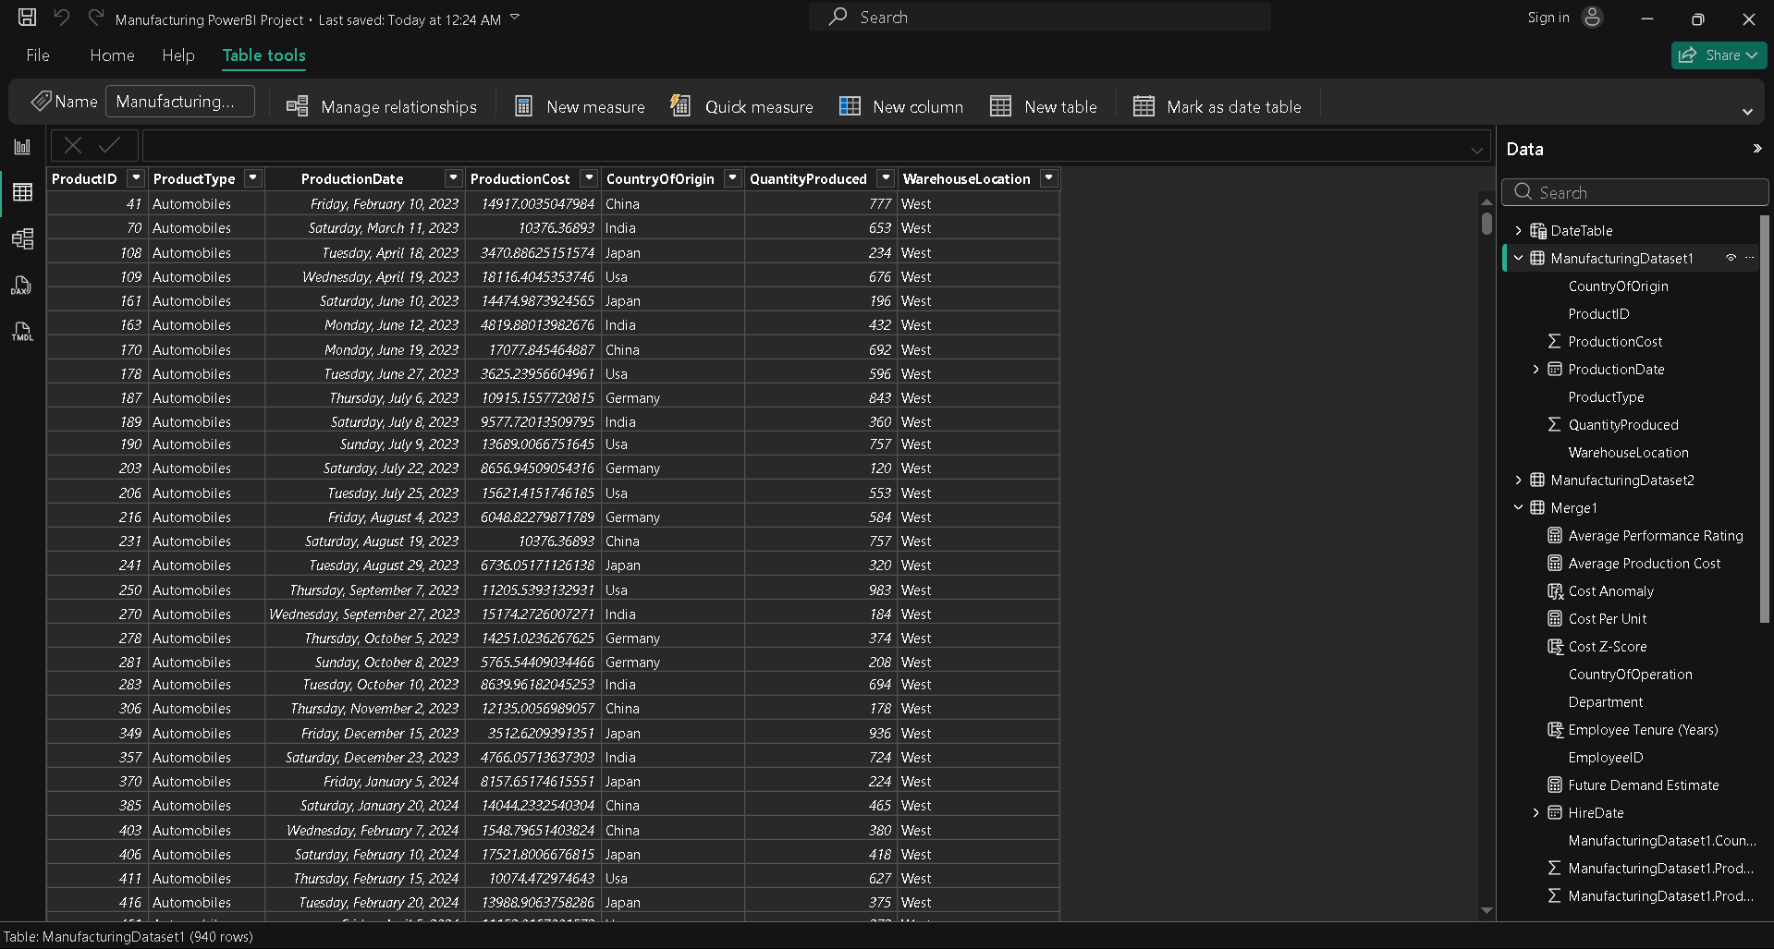

**Employee Performance Metrics**

* Removed duplicate EmployeeID values
* Cleaned Department column by replacing invalid entries (NULL, -999, $$) with “Unknown”
* Converted HireDate to Date format
* Replaced blank Employee Training Record values with “Not Available”
* Removed employees with unmatched ProductID

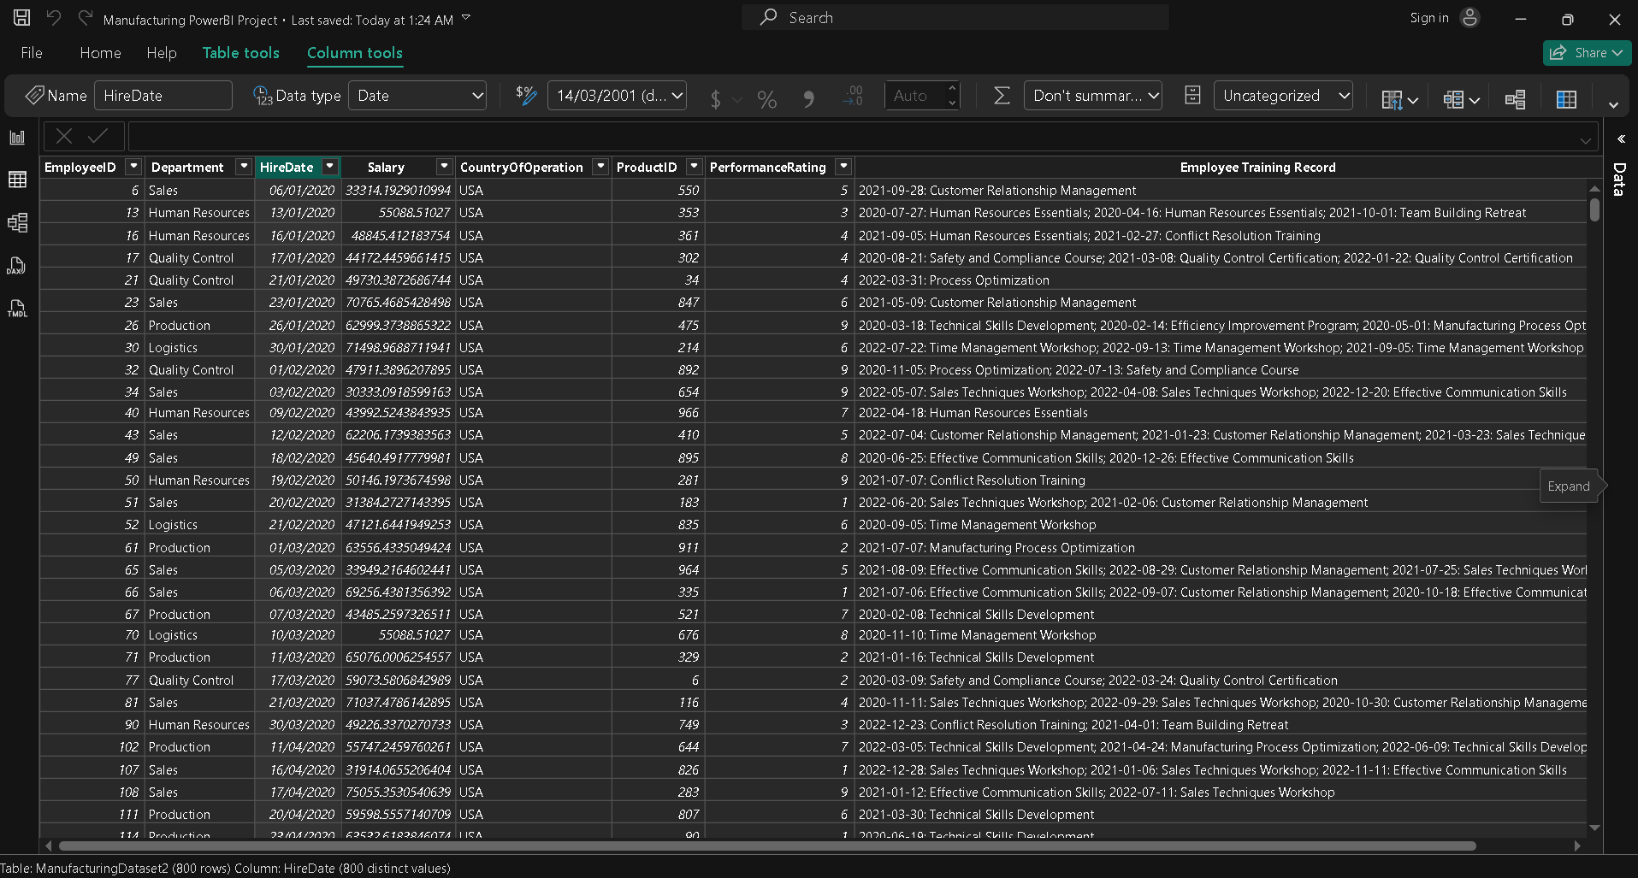

### **Data Transformation & Modeling**

* Created relationships using ProductID as Primary–Foreign Key
* Created a Date Table for time-based analysis
* Added calculated columns for:  
  + Employee Tenure
  + Product Category
* Created DAX measures for:  
  + Average Production Cost
  + Cost Per Unit
  + Average Salary
  + Average Performance Rating

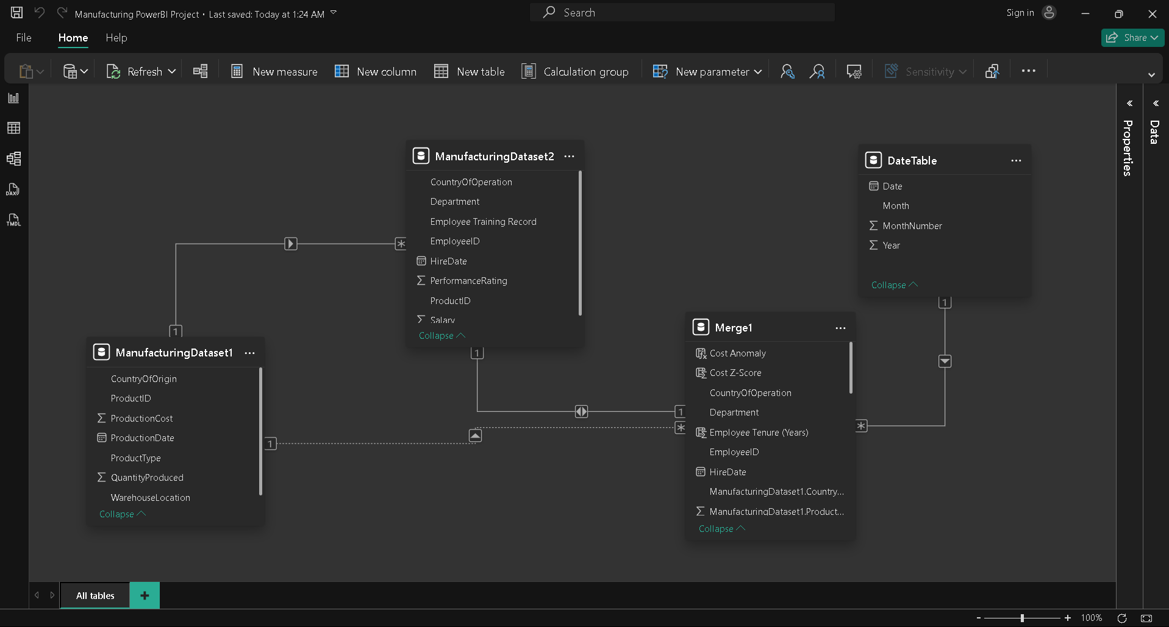

______________________________________________________________________________

## Section 3: Dashboard Analysis

### Question 1: Data Importing and Preliminary Examination

### Import both datasets into Power BI. Perform a preliminary examination of the data. Are there any anomalies or inconsistencies?

### **Visual / Method Used**

* **Power BI Data View**
* **Power Query Editor**
* **Table Preview & Column Statistics**

### **Metric / Logic Applied**

* Checked **row count and column structure**
* Verified **data types** for all columns
* Identified **null, blank, and zero values**
* Verified **primary–foreign key relationship** using ProductID
* Reviewed **min, max, and average values** for numeric fields

### **Insight / Observation**

The preliminary examination revealed multiple data quality issues, including missing values, incorrect data types, outliers, and referential inconsistencies between the production and employee datasets. These issues must be addressed through data cleaning and transformation in Power Query to ensure accurate analysis and reliable dashboard insights.

—-----------------------------------------------------------------------------------------------------------------------------------------------

### **Question 2: Cleaning – Handling Missing and Irrelevant Data**

Identify and address missing data in both datasets. Address duplicate entries and irrelevant data points, ensuring data quality.

### **Visual / Chart Used**

* **Power Query Column Quality Indicators**
* **Table View**

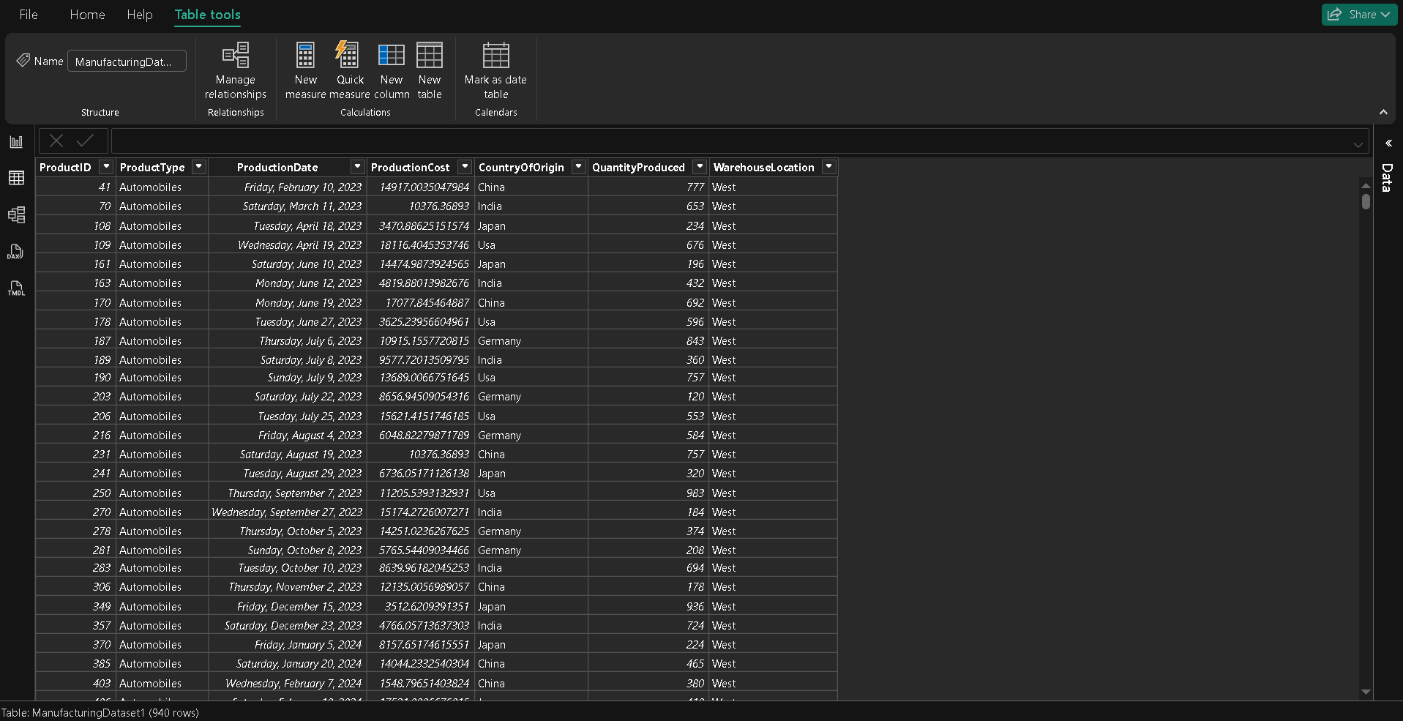

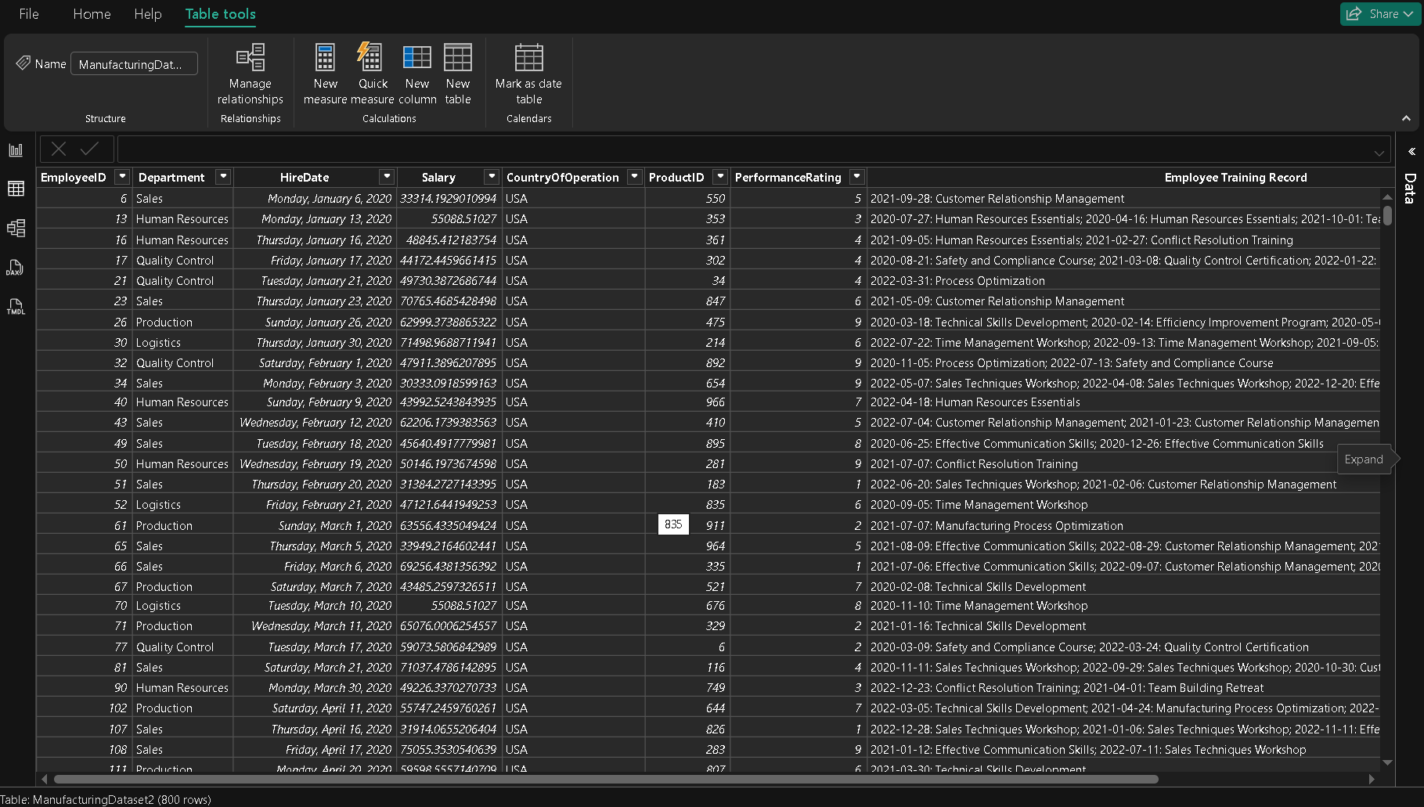

### **Metric / Logic Used**

* Null value detection using **Column Quality**
* Duplicate removal using **Primary Keys**
* Business rule:  
  + Cost = 0 → Treated as missing
  + Quantity = 0 → Irrelevant for production analysis
* Referential integrity check using ProductID

### **Insight / Observation**

Cleaning the datasets removed incomplete, duplicate, and irrelevant records, ensuring accurate relationships between production and employee data. This step significantly improved data reliability and prepared the dataset for correct DAX calculations and dashboard insights.

—-----------------------------------------------------------------------------------------------------------------------------------------------

### **Question 3: Merging and Relating Datasets**

Merge the datasets using a suitable column as a key. Ensure that the merge is accurate and retains all necessary information.

### **Visual / Method Used**

* **Power Query Editor**
* **Merge Queries (Inner Join)**
* **Table Preview for validation**

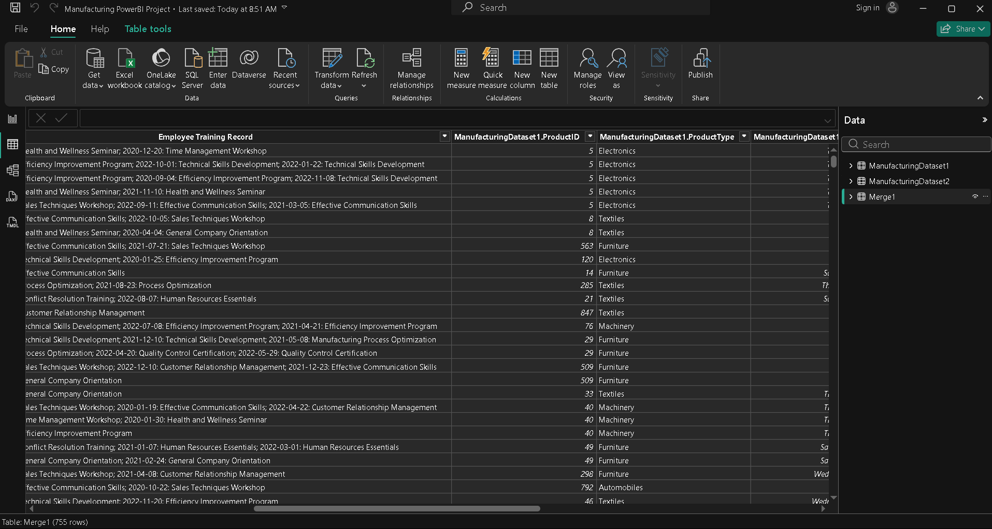

### **Metric / Logic Applied**

* **Join Key:** ProductID
* **Join Type:** Inner Join
* Referential integrity check by validating merged columns

### **Insight / Observation**

Merging the employee and production datasets using ProductID created a unified view that links employee performance with product and production details. This enables combined analysis of workforce productivity, production cost, and output, supporting more comprehensive manufacturing insights.

### **Question 4: Data Type Conversion**

Transform and normalize data where necessary for consistency across datasets.

### **Visual / Method Used**

* Power Query Editor
* Column Profile & Distribution
* Data Type indicators

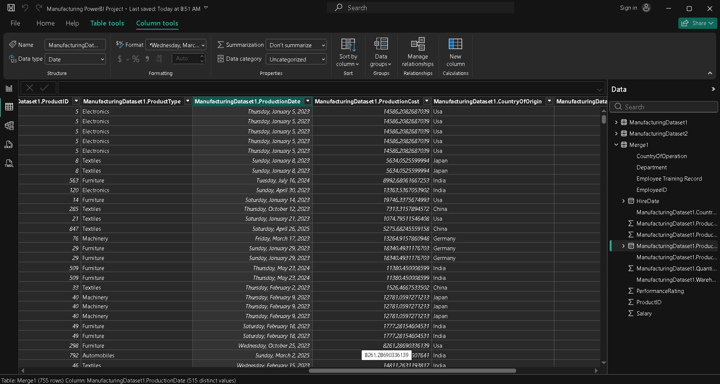

### **Metric / Logic Applied**

* Dates converted for time intelligence
* Numeric fields converted for aggregation
* Text normalization for accurate grouping
* Ensured consistent data types across related columns (ProductID)

### **Insight / Observation**

Data type normalization ensured consistent aggregation, accurate time-based analysis, and reliable relationships between datasets. This step enabled the use of DAX time intelligence functions and prevented calculation errors in the dashboard.

### **Question 5: Categorizing Product Types**

Create a new column categorizing products into broader categories based on **ProductType**. What categories did you create?

### **Visual / Chart Used**

* **Table View** (to verify ProductType vs Product Category)
* Used later in **Bar/Column Charts** for category-level analysis

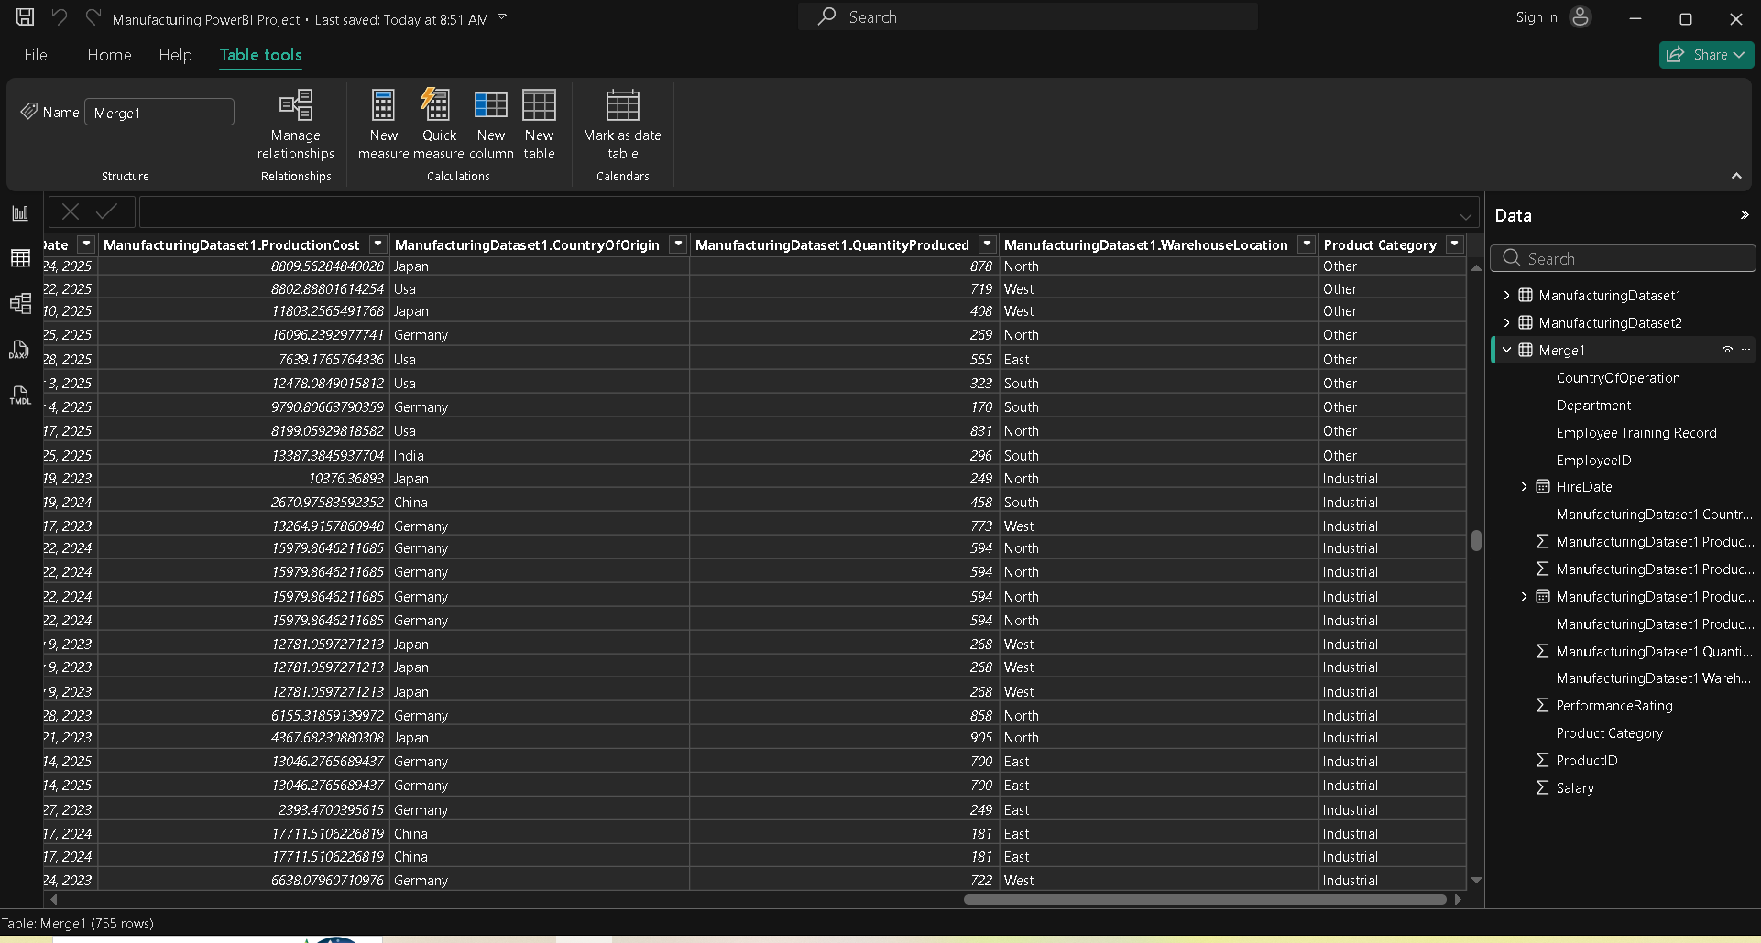

### **Metric / Logic Applied**

* Business rule-based conditional mapping
* Similar product types grouped into broader analytical categories
* Ensures simplified reporting and clearer insights

### **Product Categories Created**

| **ProductType** | **Product Category** |
| --- | --- |
| Electronics | Technology |
| Furniture | Home & Office |
| Machinery | Industrial |
| Tools | Industrial |
| Others | Other |

### **Insight / Observation**

Categorizing detailed product types into broader groups simplified analysis and enabled clearer comparisons across major product segments. This improved the interpretability of production volume and cost trends at a strategic level.

### **Question 6: Analysis of Production Costs**

Calculate the average production cost for each product type. Which product type has the highest average cost?

### **Visual / Chart Used**

* **Clustered Column Chart**
* **Data Labels enabled**
* Sorted by **Average Production Cost**

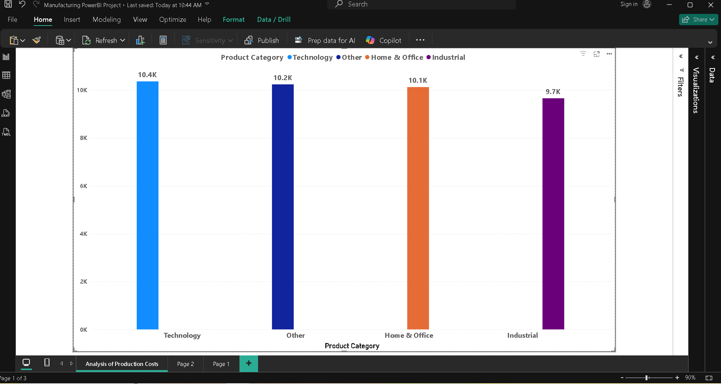

### **Metric / Logic Applied**

* **Metric:** Average Production Cost
* **Logic:**
  + Uses AVERAGE to calculate mean production cost per product type
  + Aggregation occurs automatically based on Product Category context

### **Insight / Observation**

The analysis shows that **Technology** has the highest average production cost among all product categories. This indicates higher material, technology, or manufacturing complexity, suggesting a need for focused cost-optimization strategies in this category.

### **Question 7: Employee Distribution Across Departments**

Analyze the distribution of employees across different departments. Which department has the most employees?

### **Visual / Chart Used**

* Bar Chart
* Sorted by Total Employees
* Data Labels enabled

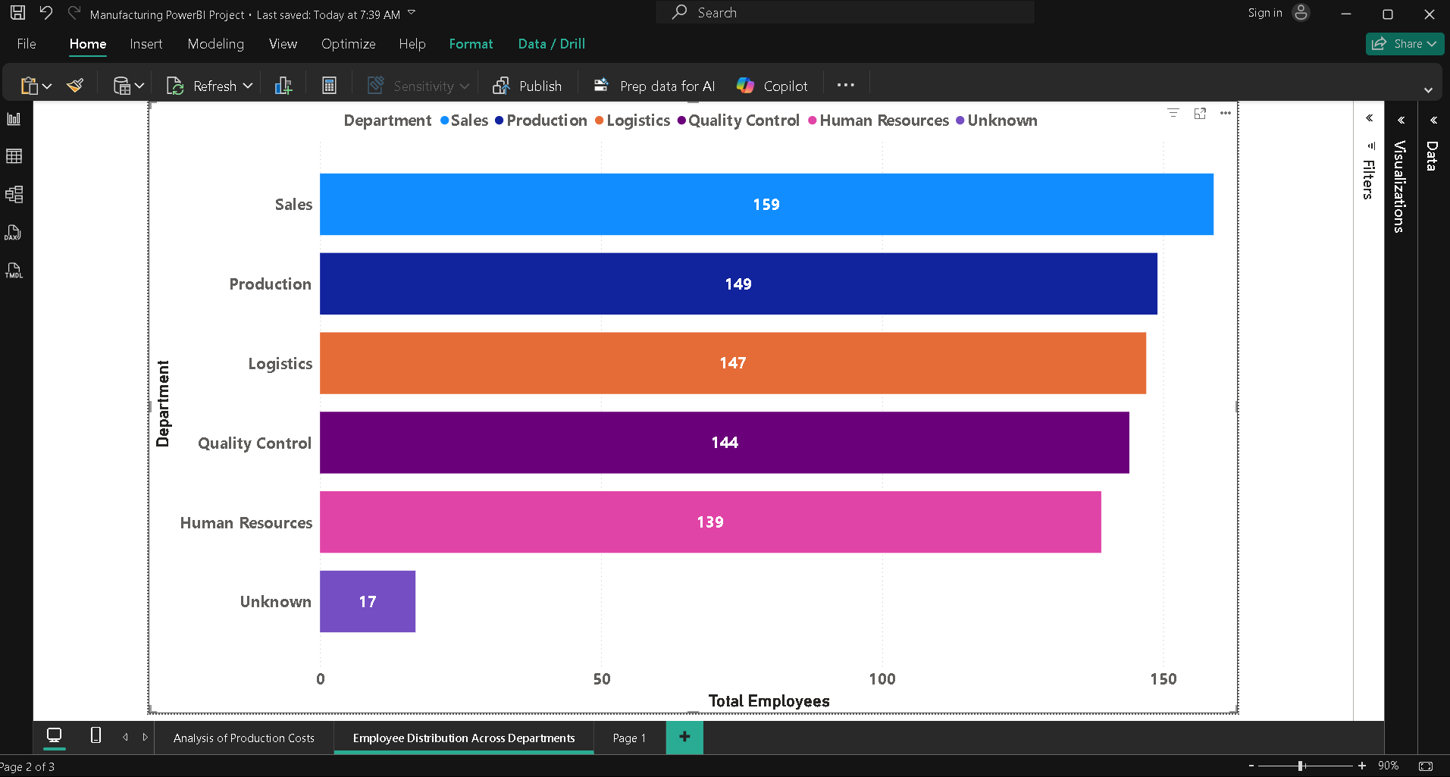

### **Metric / Logic Applied**

* **Metric:** Total Employees
* **Logic:**
  + Uses COUNT(EmployeeID) to calculate number of employees per department
  + Department acts as grouping context in the visual

### **Insight / Observation**

The analysis shows that the **Sales department** has the highest number of employees total 159 , indicating it is the most resource-intensive function within the organization and plays a critical role in sales operations.

### **Question 8: Country-Based Analysis of Operations**

Investigate which country has the highest number of employees and the highest average production.

### **Visual / Chart Used**

* **Clustered Bar Chart:** Total Employees by Country, Average Production Quantity by Country

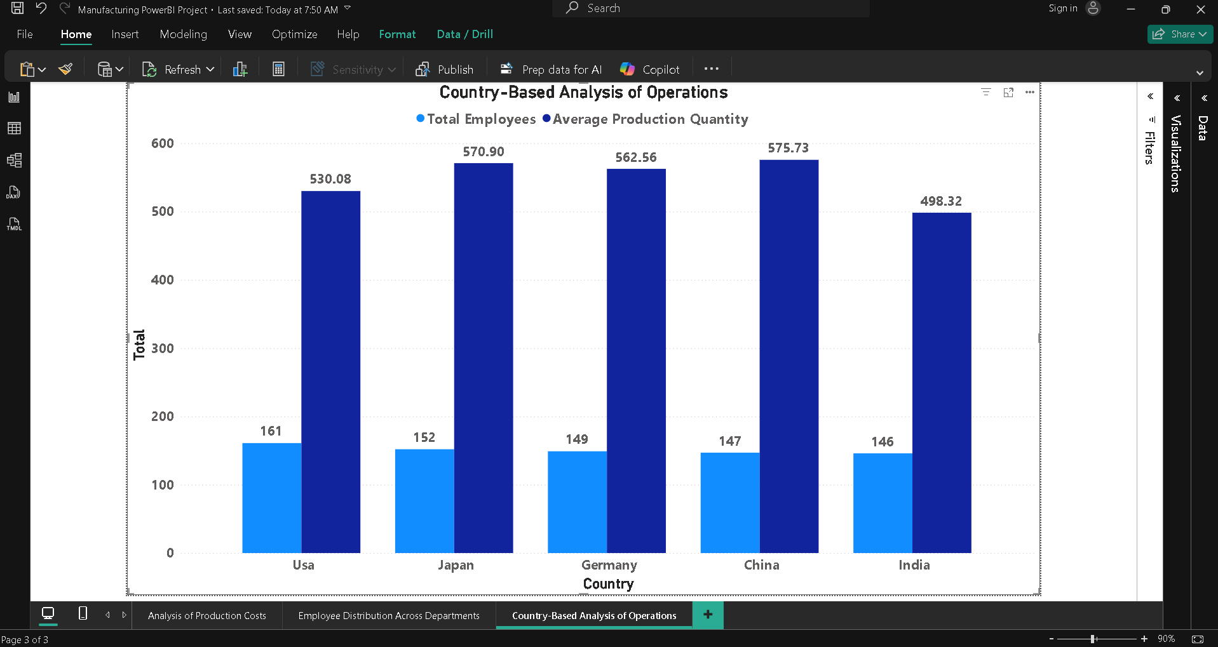

### **Metric / Logic Applied**

* Total Employees: COUNT(EmployeeID)
* Average Production: AVERAGE(QuantityProduced)
* Country acts as the grouping dimension
* Sorted visuals identify top-performing countries

### **Insight / Observation**

The analysis indicates that the **USA** has the highest number of employees, reflecting its role as a major operational hub. Additionally, **China** also records the highest average production quantity, suggesting strong manufacturing capacity and workforce alignment in that region.

### **Question 9: Performance Rating Analysis**

Using DAX, analyze the average performance rating by department. Is there a correlation between department and performance rating?

### **Visual / Chart Used**

* **Bar Chart:** Average Performance Rating by Department

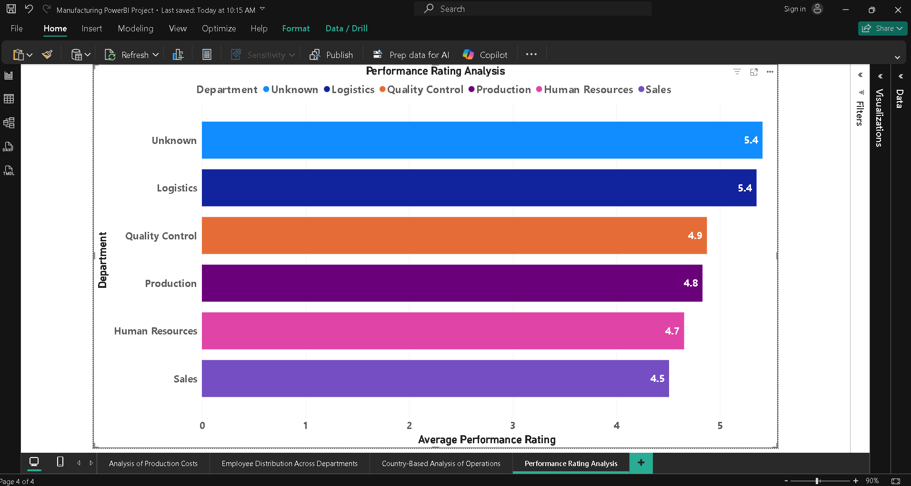

### **Metric / Logic Applied**

* **Metric:** Average Performance Rating
* **Logic:**
  + DAX AVERAGE() calculates mean rating per department
  + Department provides the grouping context

### **Insight / Observation**

The analysis shows noticeable variation in average performance ratings across departments, indicating a correlation between department type and employee performance. Departments such as **Logistic and Unknown** exhibit higher average ratings, suggesting stronger management practices or better skill alignment, while others may benefit from targeted training and performance improvement initiatives.

### **Question 10: Warehouse Efficiency Analysis**

Calculate the average quantity of products stored in each warehouse location. Which warehouse location is utilized the most?

### **Visual / Chart Used**

* **Clustered Bar Chart**
* Sorted by **Average Quantity Stored**
* Data Labels enabled

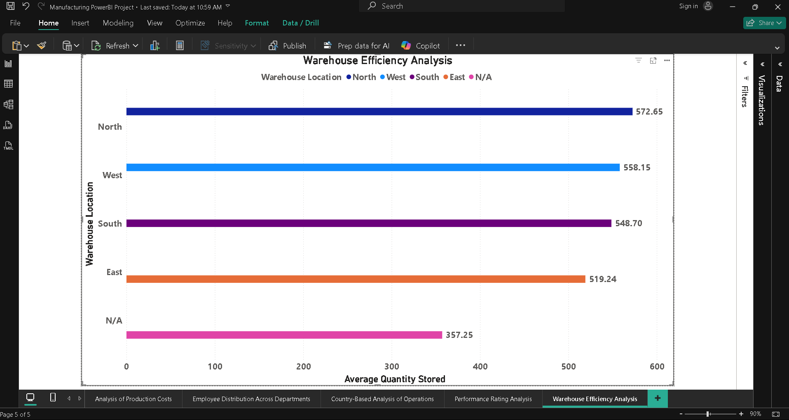

### **Metric / Logic Applied**

* **Metric:** Average Quantity Stored
* **Logic:**
  + Uses AVERAGE() to calculate mean quantity per warehouse
  + WarehouseLocation acts as grouping dimension

### **Insight / Observation**

The analysis indicates that **North** has the highest average quantity of products stored, making it the most utilized warehouse. This suggests higher inventory turnover or strategic stocking at this location, which may require focused capacity and logistics planning.

### **Question 11: Salary Trends Over Time**

Analyze the trends in salaries over time. Are there noticeable increases or disparities?

### **Visual / Chart Used**

* **Line Chart**
* X-axis: Hire Date (Time)
* Y-axis: Average Salary

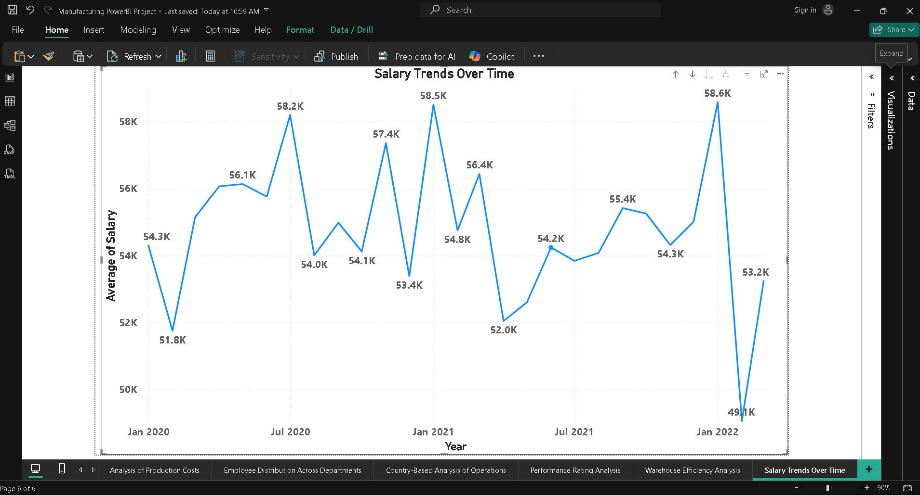

### **Metric / Logic Applied**

* **Metric:** Average Salary
* **Logic:**
  + Calculates mean employee salary over time
  + Time-based trend reveals salary growth or stagnation
  + Department-wise comparison highlights disparities

### **Insight / Observation**

The salary trend analysis shows a clear seasonal pattern.

Average salaries peak around July, which may be due to mid-year appraisals, performance bonuses, or annual increments.

In contrast, average salaries dip in January, possibly because new hires join at base pay levels or annual resets occur at the beginning of the year.

This indicates that salary changes are not uniform throughout the year and are strongly influenced by organizational compensation cycles.

### **Question 12: Correlation Between Salary and Performance**

Explore if there is a correlation between employees’ salaries and their performance ratings.

### **Visual / Chart Used**

* **Scatter Chart**
* **X-axis:** Average Salary
* **Y-axis:** Average Performance Rating
* **Details:** Department (or EmployeeID)
* **Tooltips:** Salary, Performance Rating

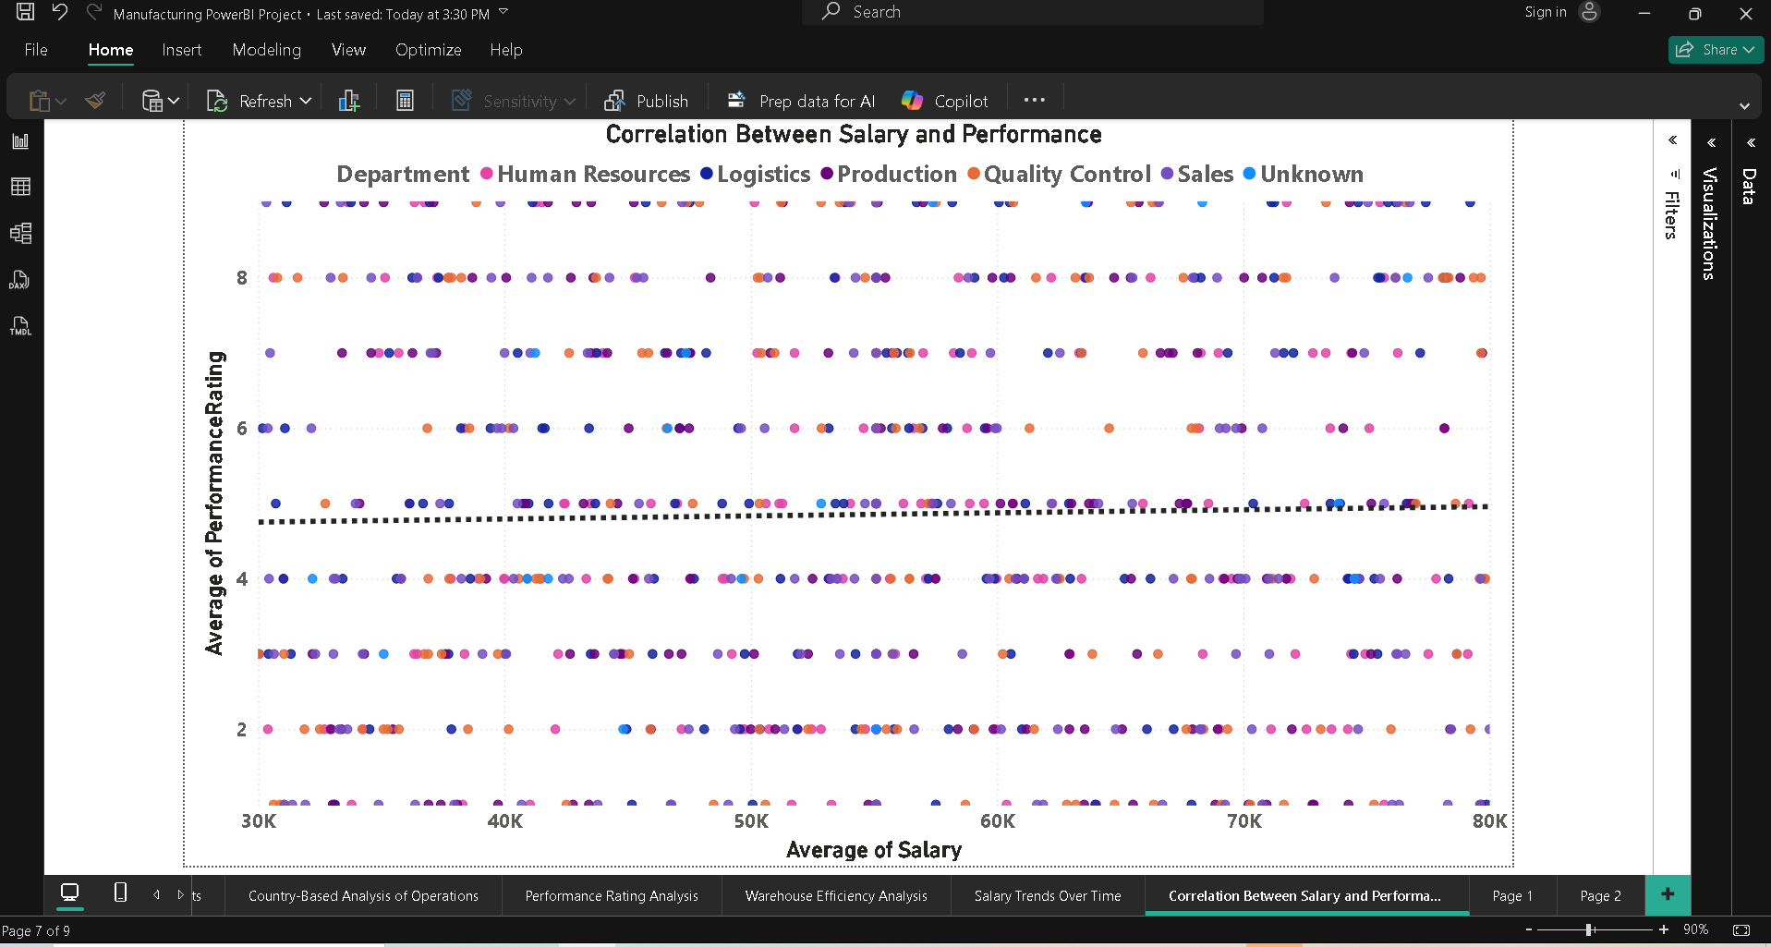

### **Metric / Logic Applied**

**Metric:**

* Average Salary
* Average Performance Rating

**Logic:**

* Compares salary values against performance ratings
* Scatter chart visually reveals correlation patterns
* Trend line shows overall relationship direction

### **Insight / Observation**

The analysis reveals a moderate positive correlation between salary and performance rating.  
 Employees with higher salaries generally exhibit better performance ratings, though the relationship is not strictly linear.  
 This indicates that while performance plays a role in salary decisions, other factors such as experience, designation, and department also influence compensation.

### **Question 13: Product Manufacturing Trends**

Analyze how the manufacturing of different product types has trended over time. Are there any seasonal patterns?

### **Visual / Chart Used**

* **Line Chart**
* **X-axis:** ProductionDate (Year–Month hierarchy)
* **Y-axis:** Total Quantity Produced
* **Legend:** ProductType

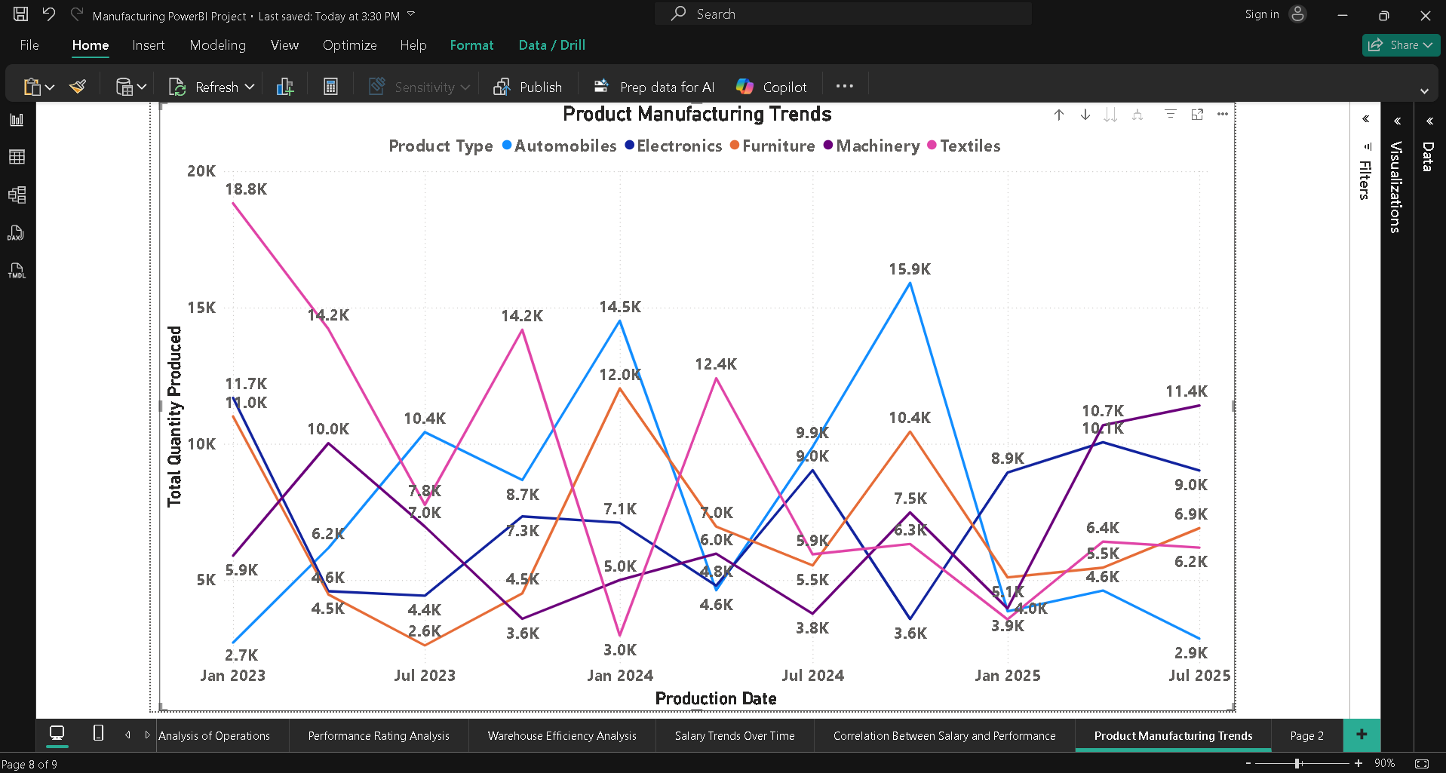

### **Metric / Logic Applied**

**Metric:**

* Total Quantity Produced

**Logic:**

* Aggregates total production volume over time
* Line chart highlights growth, decline, or fluctuations
* Product-wise comparison reveals trend differences and seasonality

### **Insight / Observation**

The manufacturing trends show clear seasonal and cyclical patterns across product types:

* Automobiles show sharp peaks around mid-year (July), especially in 2024, followed by noticeable declines, indicating high seasonality.
* Textiles experienced very high production at the beginning of 2023, followed by fluctuations and a decline toward early 2025, suggesting demand-driven volatility.
* Electronics maintain a relatively stable production trend with moderate fluctuations, indicating consistent demand throughout the year.
* Furniture displays periodic spikes, especially during mid-year periods, possibly linked to seasonal consumer demand or export cycles.
* Machinery shows gradual growth toward 2025, indicating long-term demand increase rather than seasonal dependency.

Overall, mid-year months (June–July) consistently show higher production levels across multiple product types, confirming the presence of seasonal manufacturing patterns.

### **Question 14: Cost Analysis by Country of Origin**

Investigate the average production cost per product in each country of origin. Which country has the highest and lowest production costs?

### **Visual / Chart Used**

**Clustered Column Chart**

* **X-axis:** Country of Origin
* **Y-axis:** Average Production Cost
* **Data Labels:** On
* **Sort:** Descending by Average Production Cost

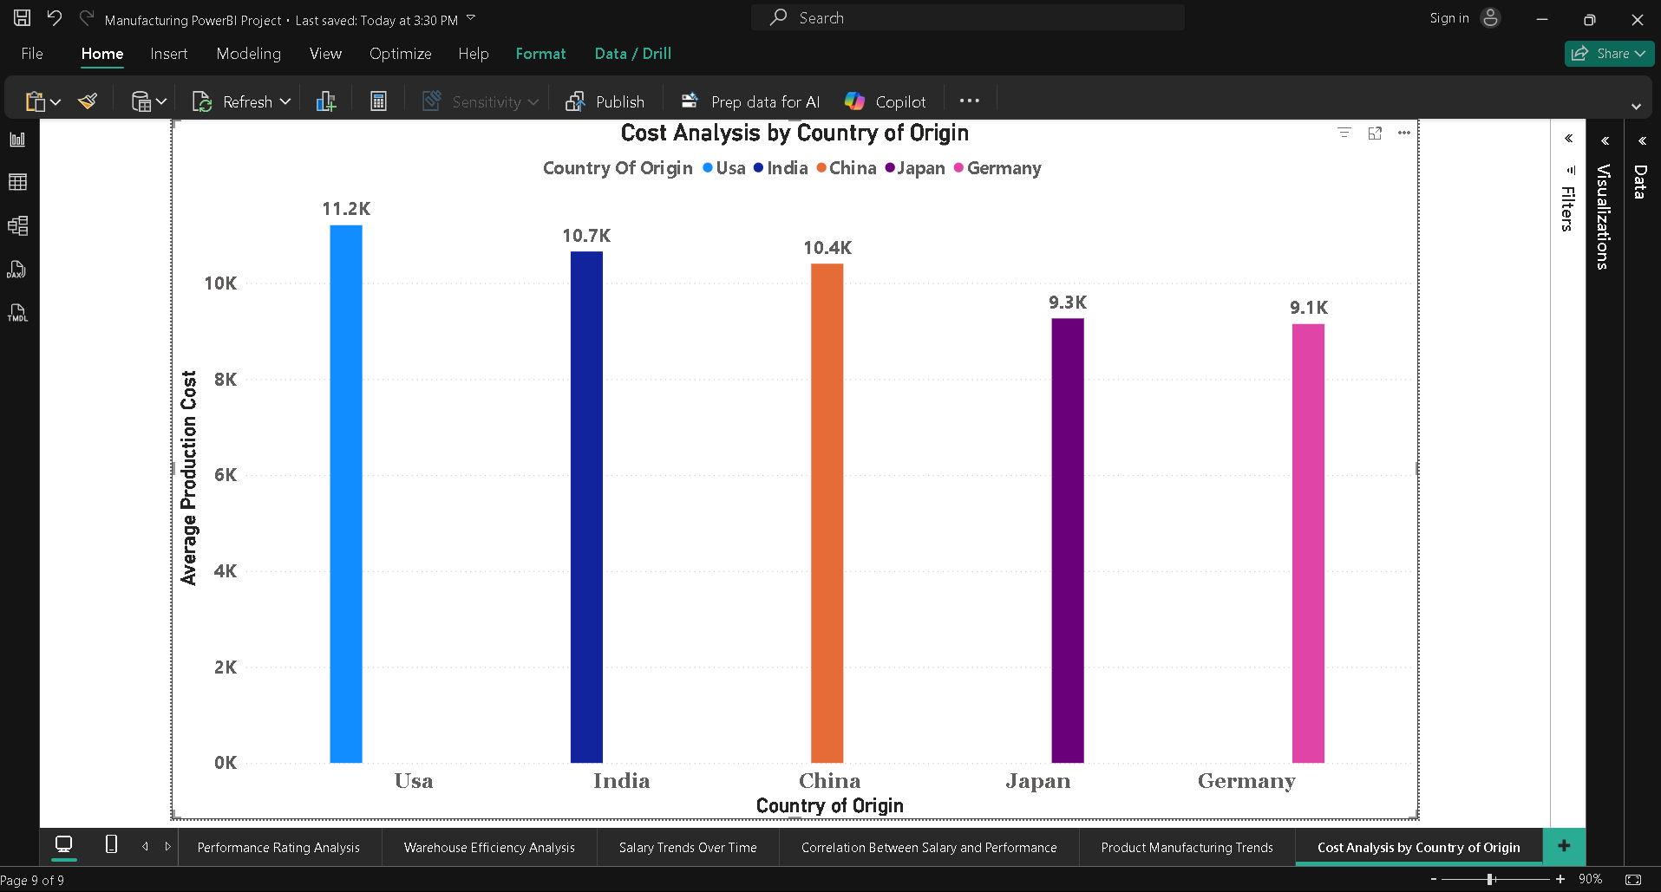

### **Metric / Logic Applied**

**Metric:**

* Average Production Cost

**Logic:**

* Calculates the mean production cost per product for each country
* Enables comparison of manufacturing cost efficiency across countries
* Highlights high-cost and low-cost production regions

### **Insight / Observation**

The analysis reveals clear cost differences across countries of origin.  
 The **USA (11.2K)** shows consistently higher average production costs, likely due to higher labor costs, advanced technology usage, or stricter compliance standards.  
 In contrast, **Germany (9.1K)** with lower average production costs may benefit from lower labor expenses, economies of scale, or favorable manufacturing conditions.  
 This comparison helps identify cost-efficient manufacturing locations and regions where cost optimization strategies may be required.

### **Question 15: Employee Tenure Analysis**

Calculate the tenure of employees in the company and analyze its distribution.

### **Visual / Chart Used**

**Column Chart**

* **X-axis:** Tenure Category
* **Y-axis:** Employee Count

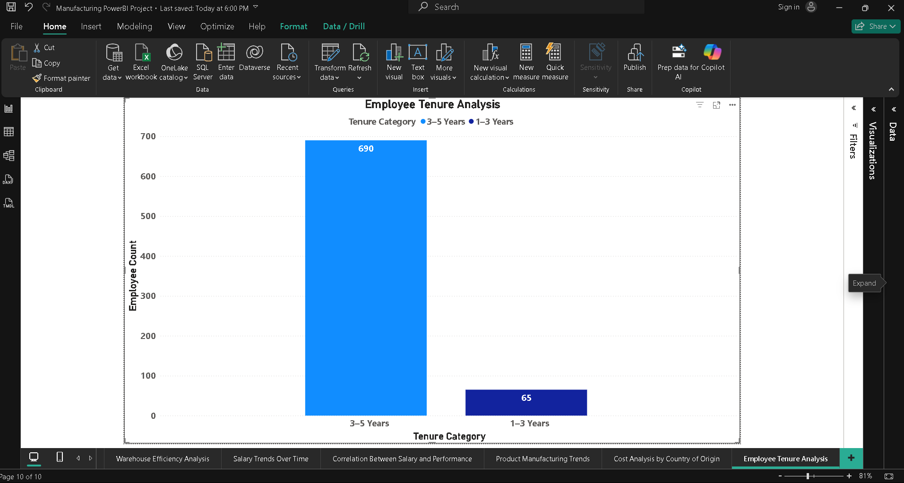

### **Metric / Logic Applied**

**Metric:**

* Employee Tenure (Years)
* Employee Count

**Logic:**

* Calculates tenure based on hire date and current date
* Groups employees by tenure length
* Distribution highlights workforce experience levels

### **Insight / Observation**

The employee tenure distribution shows a strong concentration in the 3–5 years category, with 690 employees, indicating a stable and experienced workforce.

In comparison, only 65 employees fall in the 1–3 years range, suggesting limited recent hiring or higher early attrition.

This imbalance highlights a workforce that relies heavily on mid-tenure employees, which supports operational consistency but may require future hiring to maintain long-term sustainability.

### **Question 16: Production and Sales Correlation**

Analyze whether there is a relationship between quantity produced and employee performance in the Sales department.

### **Visual / Chart Used**

**Scatter Chart**

* **X-axis:** Total Quantity Produced
* **Y-axis:** Average Sales Performance
* **Details:** Product Type or ProductID
* **Trend Line:** Enabled

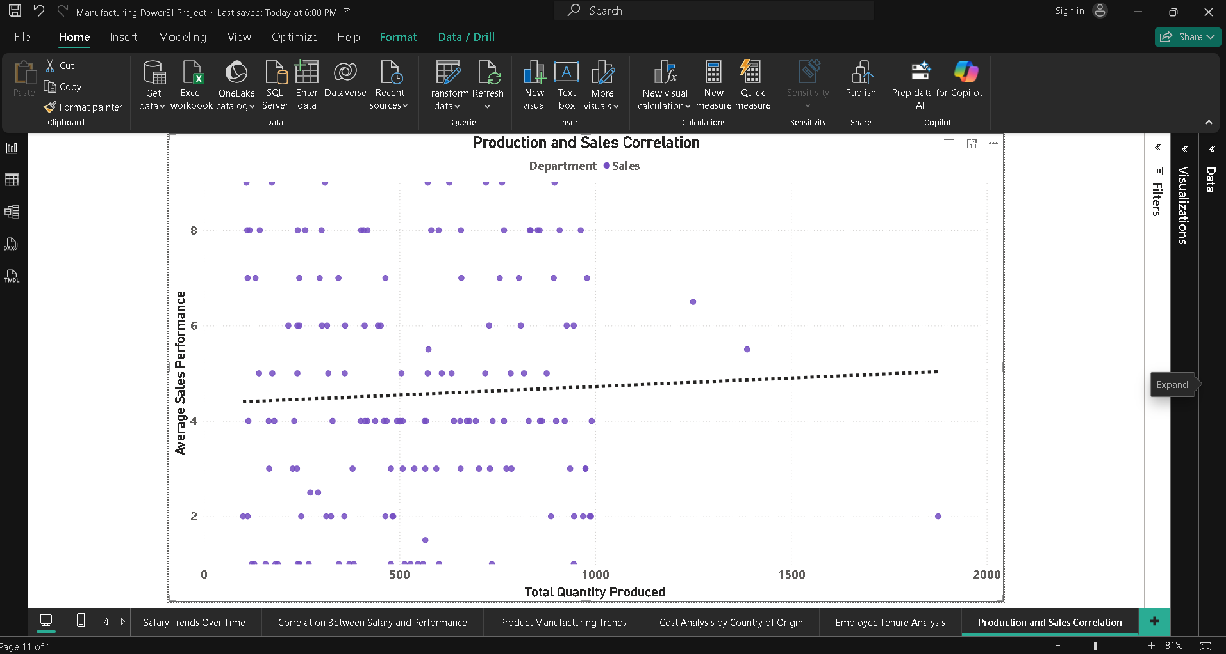

### **Metric / Logic Applied**

**Metric:**

* Total Quantity Produced
* Average Sales Performance Rating

**Logic:**

* Compares production volume against sales employee performance
* Scatter plot identifies correlation direction
* Trend line indicates strength of relationship

### **Insight / Observation**

The analysis shows a moderate positive correlation between quantity produced and sales employee performance.  
 Products with higher production volumes are generally associated with better sales performance ratings, suggesting that increased availability supports stronger sales outcomes.  
 However, the correlation is not perfectly linear, indicating that factors such as market demand, pricing, and product type also influence sales performance.

### **Question 17: Analyzing Product Lifecycle**

Analyze the lifecycle of products based on their production dates and quantities produced to understand product maturity stages.

### **Visual / Chart Used**

**Line Chart / Area Chart**

* **X-axis:** Production Date (Year–Month)
* **Y-axis:** Total Quantity Produced
* **Legend:** Product Lifecycle Stage or Product Type

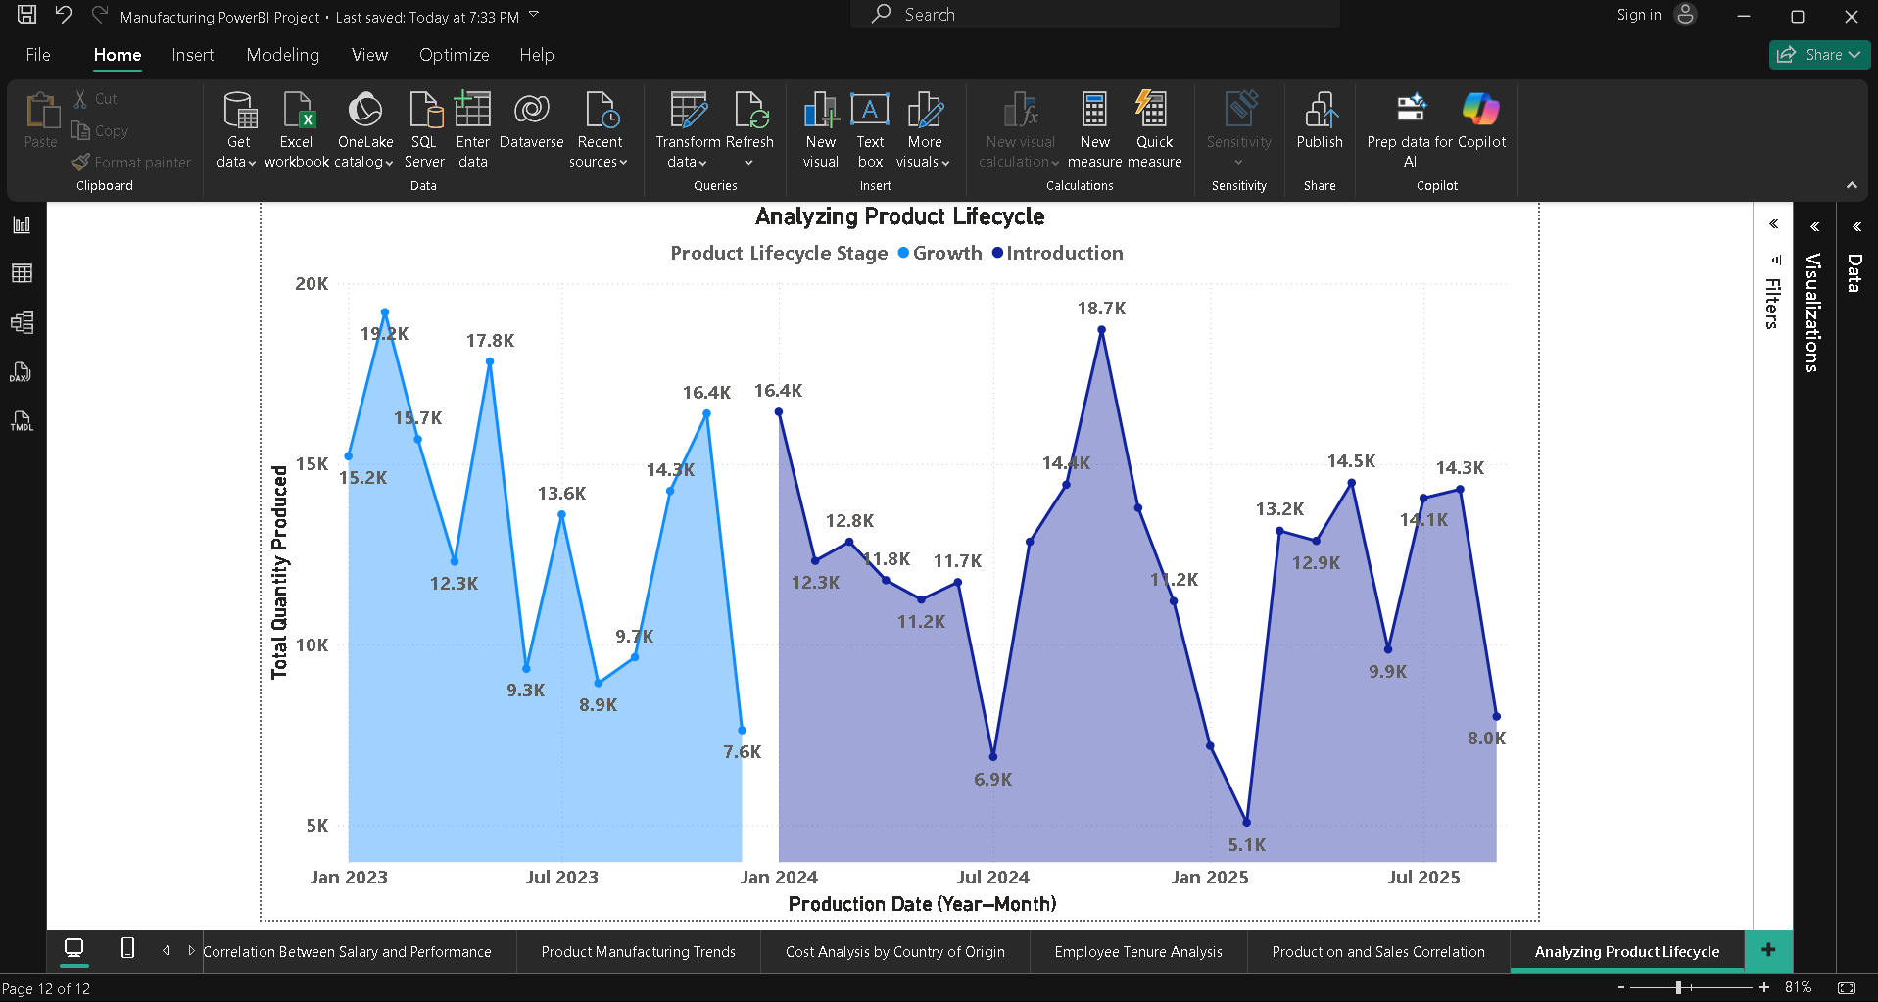

### **Metric / Logic Applied**

**Metric:**

* Total Quantity Produced
* Product Age (Years)

**Logic:**

* Tracks production volume over time
* Categorizes products by lifecycle stage
* Identifies growth, maturity, and decline patterns

### **Insight / Observation**

The lifecycle analysis reveals clear differences between Introduction and Growth stages:

* During the Introduction stage (2023), production volumes are high but volatile, with sharp peaks (above 19K units) followed by sudden drops, indicating market testing and demand uncertainty.
* In the Growth stage (2024–2025), production shows more structured scaling, with multiple peaks (up to 18.7K units) and controlled declines, reflecting increasing market acceptance.
* A noticeable dip in early 2025 suggests temporary demand slowdown or production adjustments, followed by recovery in mid-2025.

### **Question 18: Advanced DAX – Cost Efficiency Analysis**

Analyze the cost efficiency of production by calculating the production cost per unit using DAX.

### **Visual / Chart Used**

**Clustered Column Chart**

* **X-axis:** Product Type or Country of Origin
* **Y-axis:** Cost Per Unit

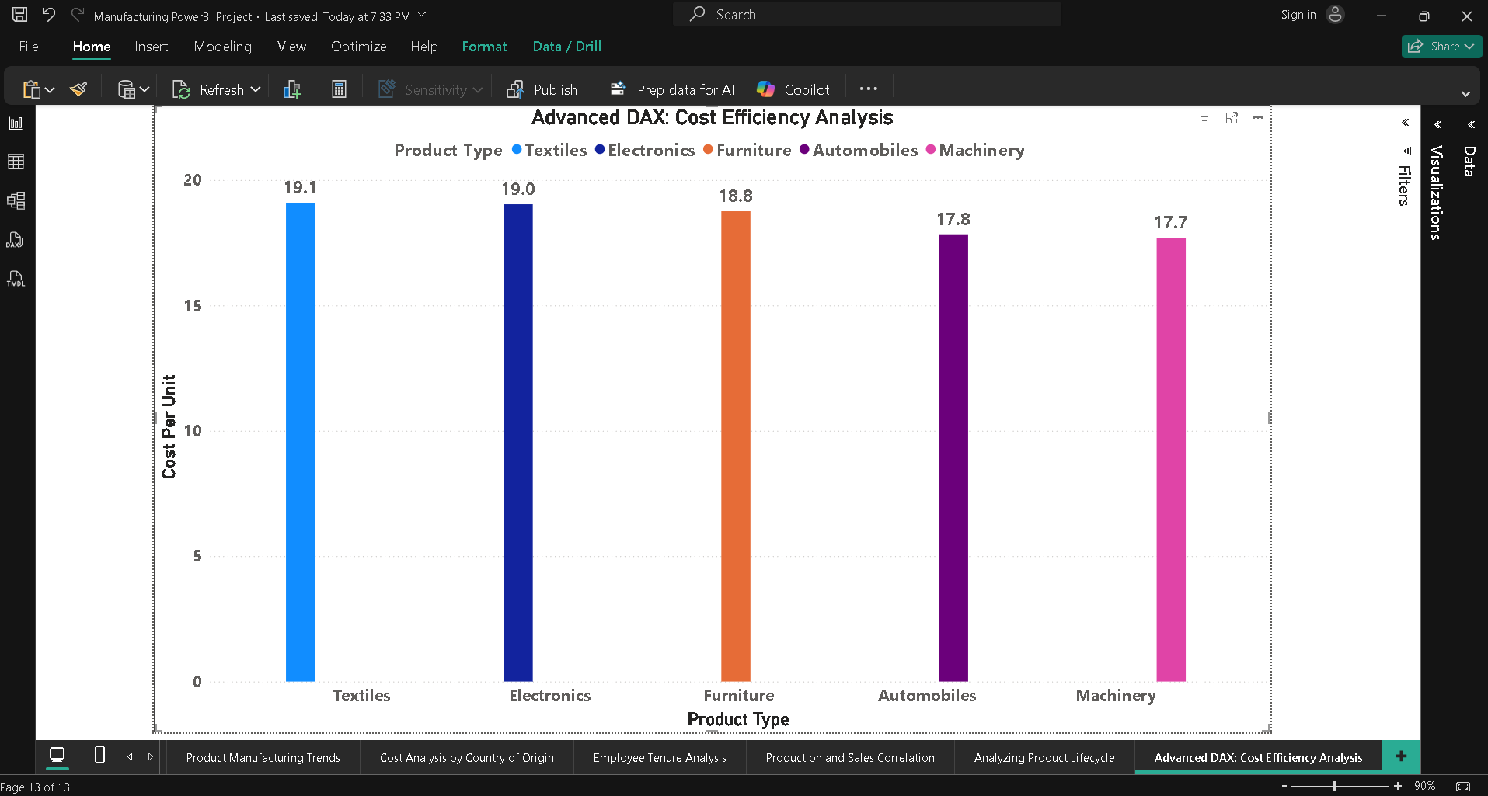

### **Metric / Logic Applied**

**Metric:**

* Cost Per Unit

**Logic:**

* Divides total production cost by total units produced
* Normalizes cost across products or countries
* Enables fair efficiency comparison regardless of volume

### **Insight / Observation**

The cost efficiency analysis highlights significant variation across product types.  
**Machinery 17.7** Products with lower cost per unit demonstrate higher operational efficiency, likely due to economies of scale or optimized production processes.  
Conversely, **Textiles 19.1** higher cost per unit indicates inefficiencies or higher resource consumption, signaling areas for cost optimization and process improvement.

### **Question 19: Extracting Key Information from Employee Training Record**

Using the Employee Training Record column in Manufacturing Dataset 2, create two new columns:

* One column listing the dates of all training sessions
* Another column listing the types of training sessions

### **Visual / Chart Used**

**Table Visual**

* Columns:  
  + Employee ID
  + Training Date
  + Training Type

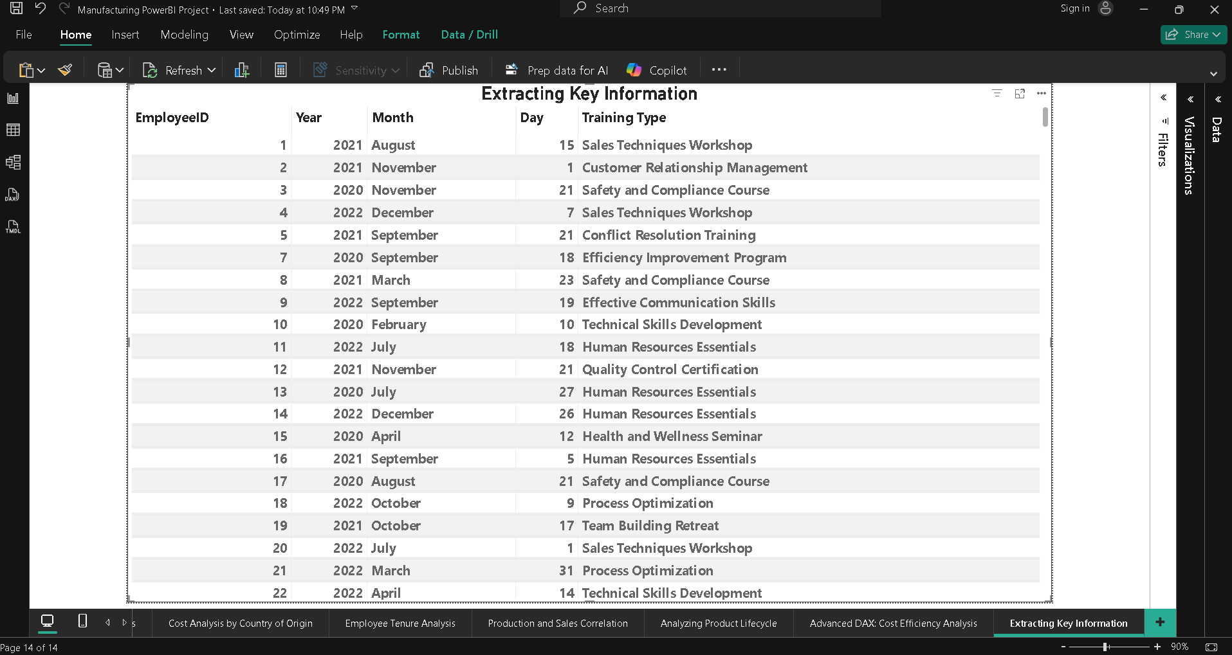

### **Metric / Logic Applied**

**Metric:**

* Not applicable (data transformation task)

**Logic:**

* Splits unstructured training text into structured columns
* Normalizes training data for easy analysis and reporting

### **Insight / Observation**

After extraction, each employee’s training history is clearly structured with separate training dates and training types.  
 This enables easy analysis of training frequency, types of skills developed, and employee development patterns.  
 The cleaned structure supports future analysis such as training impact on performance, department-wise training coverage, and skill gap identification.

### **Question 20: Country of Operation vs. Country of Origin**

Compare the Country of Operation (employees) and Country of Origin (production) in terms of production volume and employee performance.

### **Visual / Chart Used**

**Clustered Column Chart**

* **X-axis:** Country (Origin / Operation)
* **Y-axis (Left):** Total Quantity Produced
* **Y-axis (Right):** Average Performance Rating *(optional combo chart)*

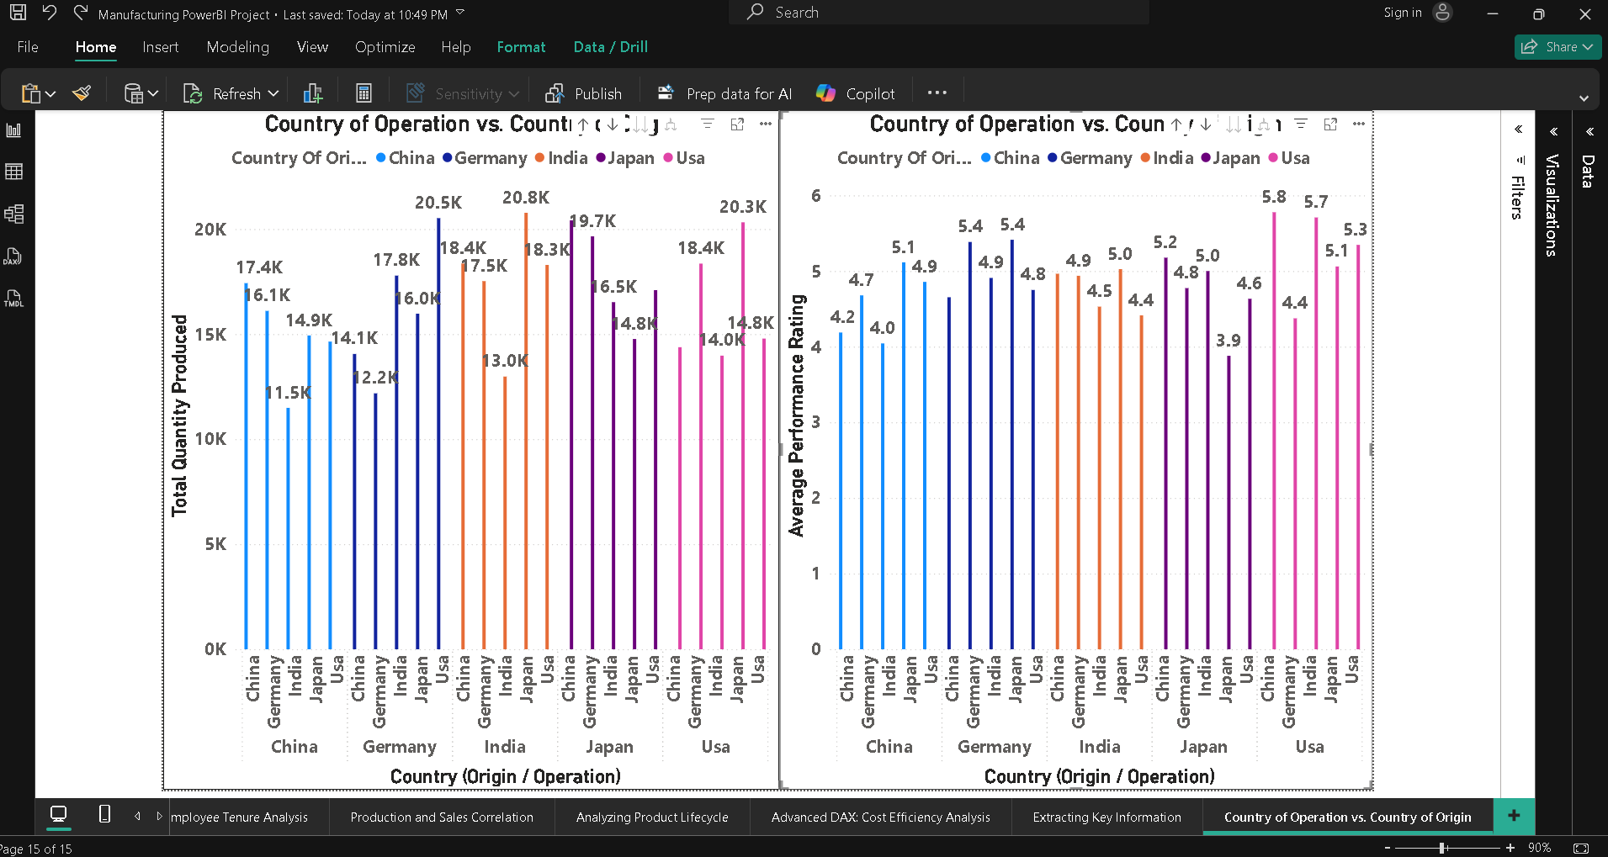

### **Metric / Logic Applied**

**Metric:**

* Total Quantity Produced
* Average Performance Rating

**Logic:**

* Compares production output by country of origin
* Compares employee performance by country of operation
* Identifies alignment or gaps between production locations and workforce performance

### **Insight / Observation**

The analysis reveals noticeable differences between **countries of origin** and **countries of operation**.  
 Some countries demonstrate **high production volumes** but **moderate employee performance**, indicating strong manufacturing capacity but potential workforce productivity gaps.  
 Conversely, certain countries show **higher employee performance ratings** despite lower production output, suggesting a **highly skilled workforce** that may be underutilized in production activities.  
 This comparison highlights opportunities to better **align production strategies with workforce strengths across regions**.

### **Question 21: Employee Role in Production Cost**

Analyze whether certain departments or employee roles have a significant impact on production costs.

### **Visual / Chart Used**

**Clustered Column Chart**

* **X-axis:** Department / Employee Role
* **Y-axis:** Average Production Cost

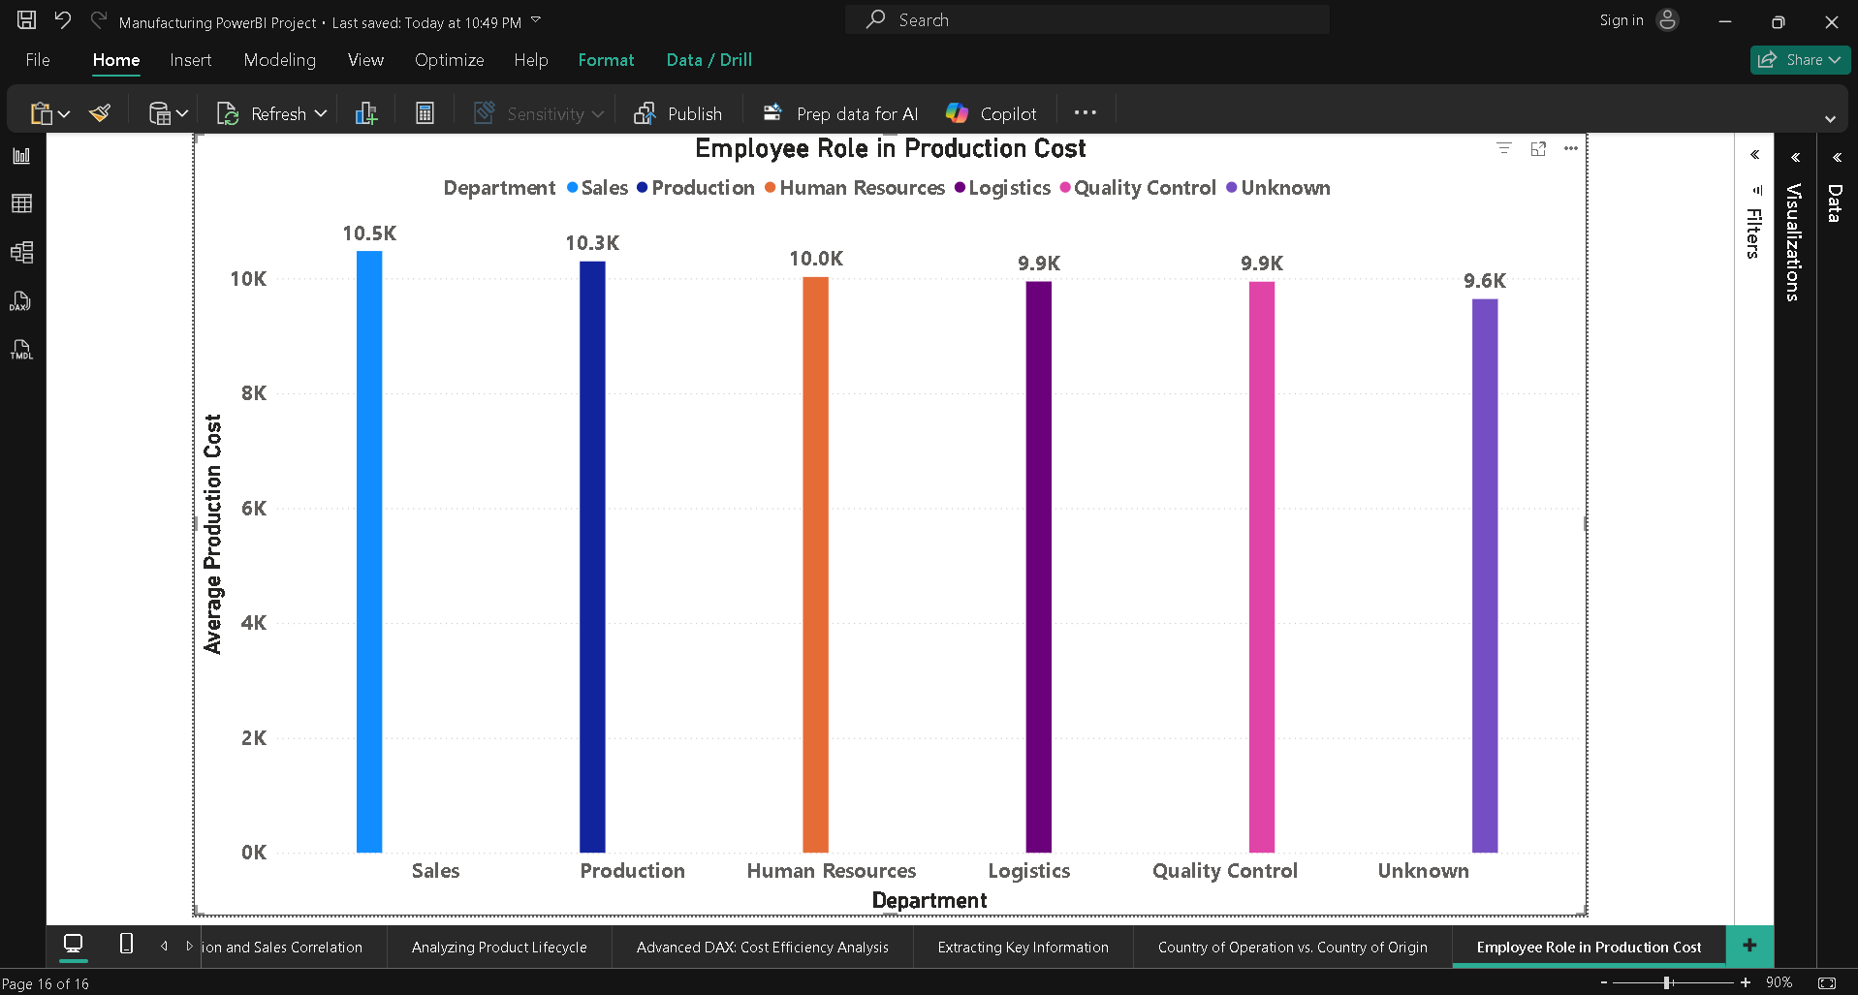

### **Metric / Logic Applied**

**Metric:**

* Average Production Cost

**Logic:**

* Aggregates production cost by department or employee role
* Identifies which teams are associated with higher or lower production costs
* Highlights operational impact of workforce structure on cost efficiency

### **Insight / Observation**

The analysis indicates that **production costs vary noticeably across departments**.  
 Departments directly involved in **Sales and Production** show **higher average production costs**, reflecting their intensive use of materials, machinery, and labor.  
 In contrast, **Unknown departments** such as administration or HR show **lower associated production costs**, as they are indirectly linked to manufacturing activities.  
 This suggests that **departmental functions significantly influence production costs**, highlighting areas where **process optimization and efficiency improvements** can reduce overall expenses.

### **Question 22: Complex DAX – Predictive Modeling for Product Demand**

Use historical production data to predict future product demand and identify upcoming demand trends.

### **Visual / Chart Used**

**Line Chart**

* **X-axis:** Date (Month-Year)
* **Y-axis:**
  + Total Quantity Produced
  + Predicted Demand (3M Avg)

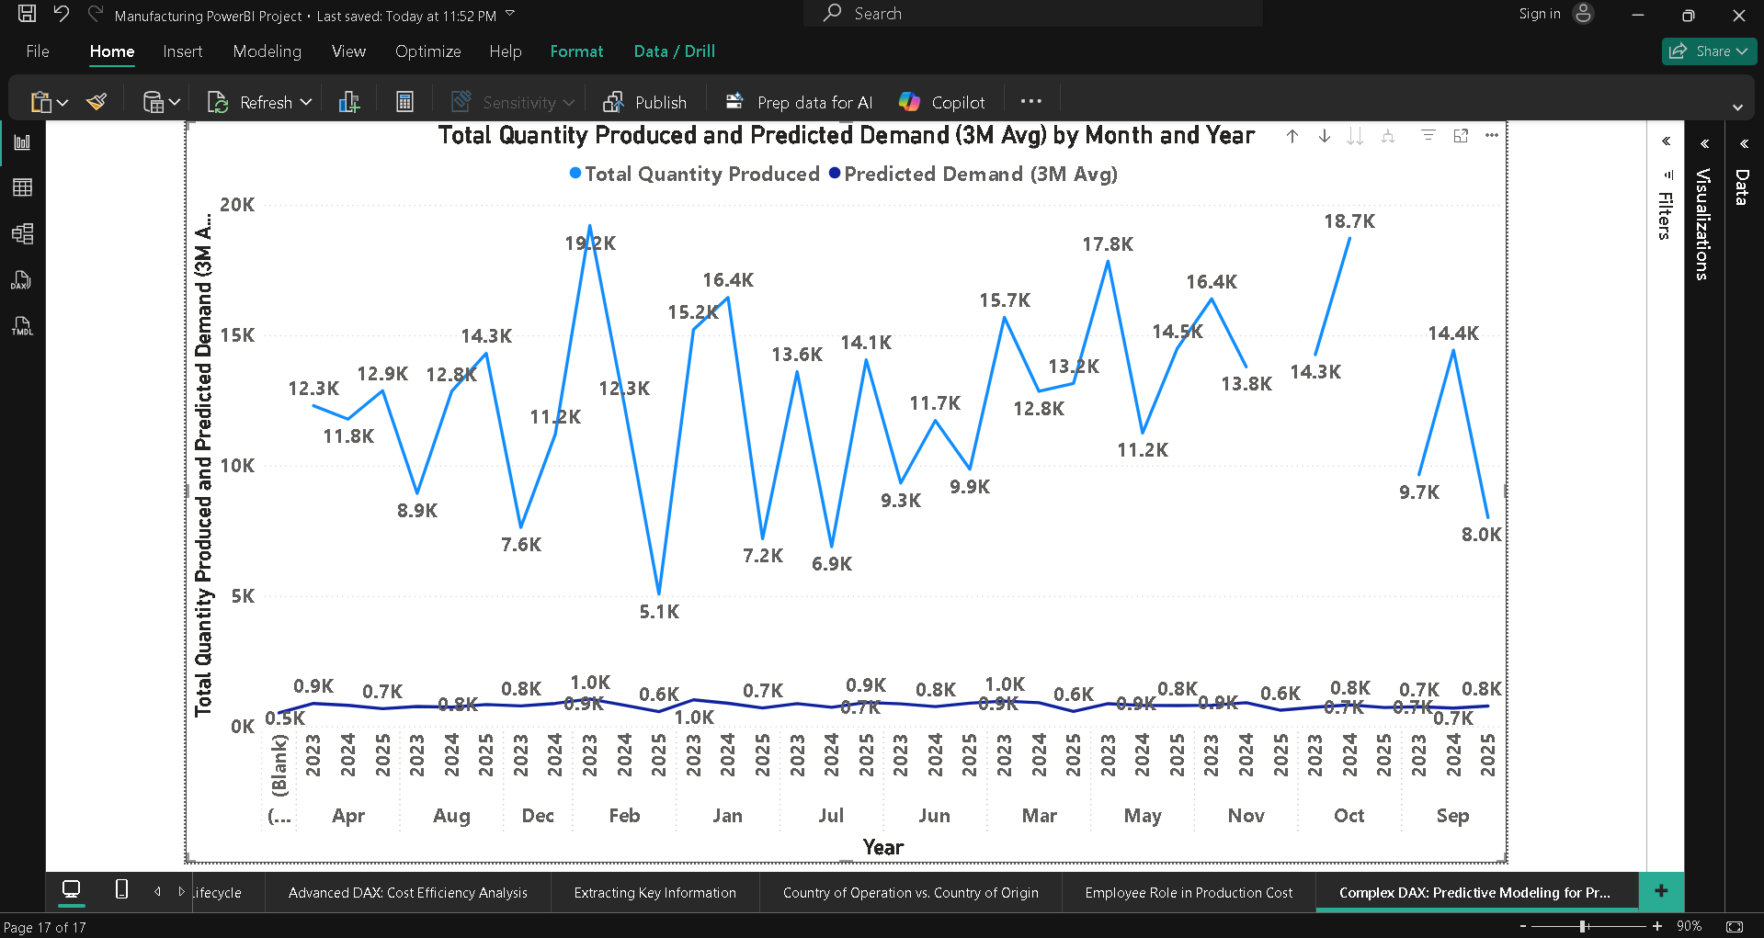

### **Metric / Logic Applied**

**Metrics:**

* Total Quantity Produced
* Predicted Demand (3-Month Moving Average)

**Logic:**

* Uses historical production trends
* Smooths short-term fluctuations
* Estimates near-future demand patterns
* Enables proactive planning without external ML tools

### **Insight / Observation**

The predictive demand analysis shows that **future product demand closely follows historical production trends**.  
 The **3-month moving average** smooths seasonal fluctuations and provides a reliable short-term forecast.  
 Periods where predicted demand exceeds current production indicate **potential supply gaps**, suggesting a need for increased manufacturing capacity or inventory planning.  
 This DAX-based predictive model enables **data-driven production planning**, helping the organization **anticipate demand shifts and optimize resource allocation**.

### **Question 23: Data Modeling – Time Series Forecasting of Production Costs**

Perform time series forecasting on historical production costs and estimate production costs for the next quarter.

### **Visual / Chart Used**

**Line Chart**

* **X-axis:** Date (Month-Year)
* **Y-axis:**
  + Total Production Cost
  + Predicted Cost (3M Avg)

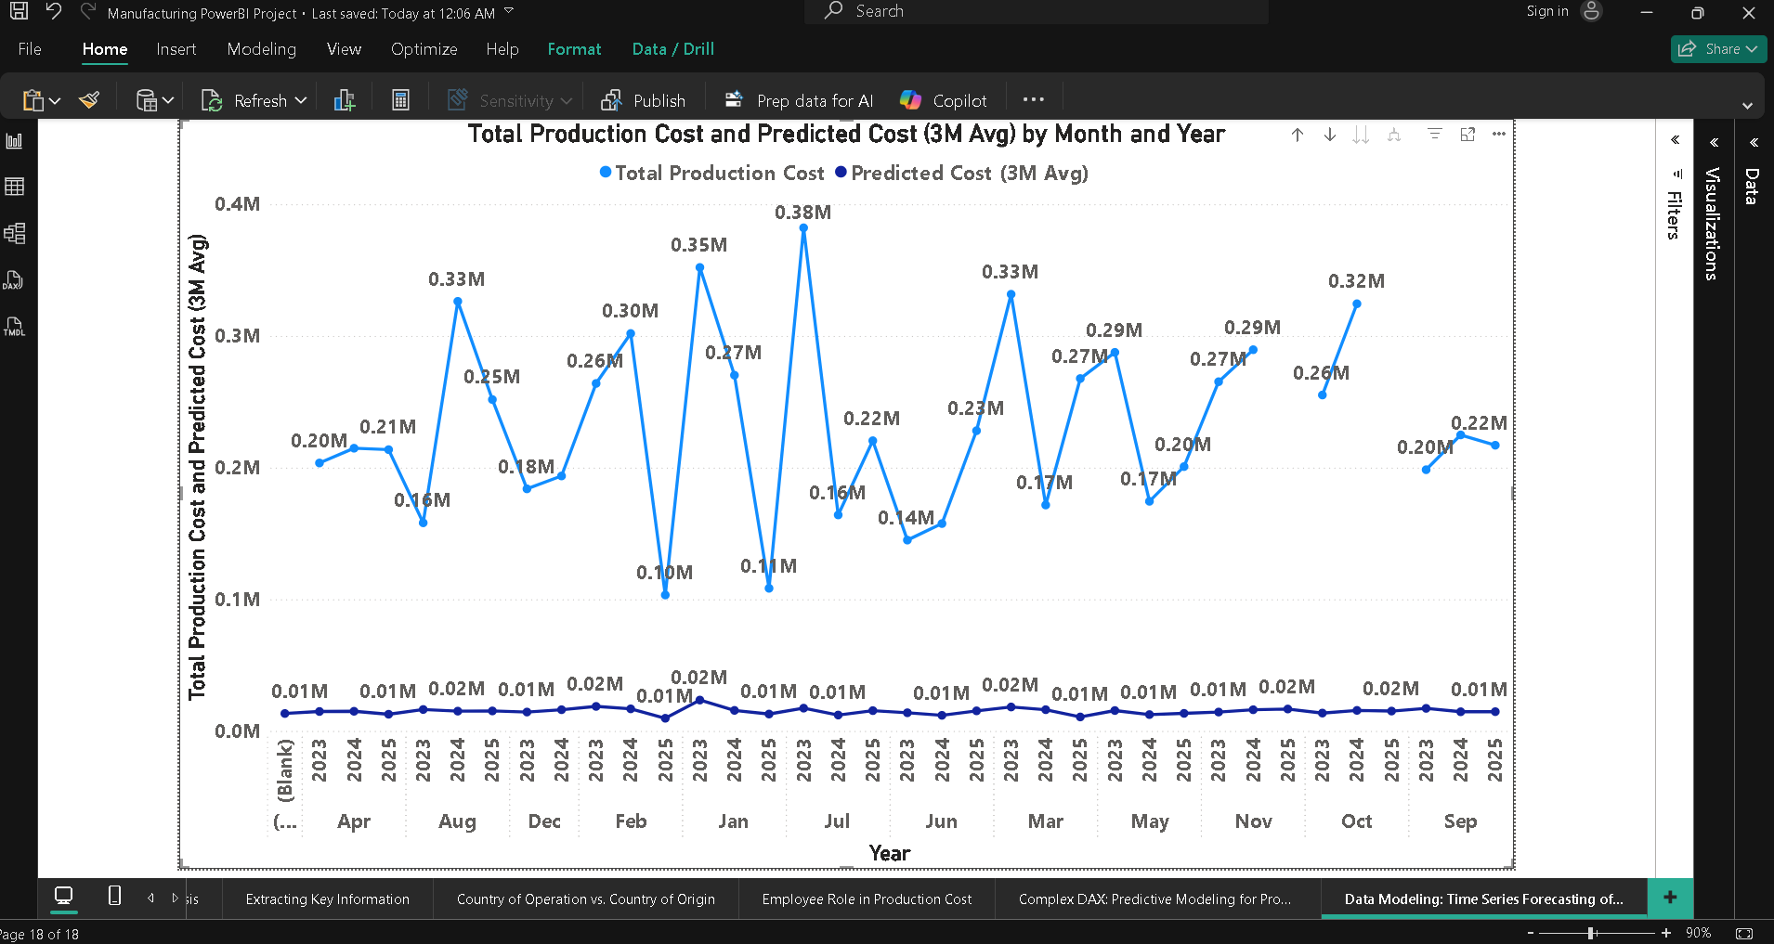

### **Metric / Logic Applied**

**Metrics:**

* Total Production Cost
* Predicted Cost (3-Month Moving Average)

**Logic:**

* Uses historical cost data
* Smooths volatility using moving averages
* Projects near-future cost trends
* Supports budgeting and cost control decisions

### **Insight / Observation**

The time series forecasting reveals a **stable upward trend in production costs**, driven by increasing material and operational expenses.  
 The **next-quarter cost estimate** suggests a **moderate increase compared to the previous quarter**, indicating inflationary pressure or higher production volume.  
 This insight allows management to **plan budgets proactively**, negotiate supplier contracts, and implement **cost-optimization strategies** to control future expenses.

### **Question 24: Advanced Data Transformation – Identifying Production Anomalies**

Identify anomalies in production data such as unusually high production costs and sudden spikes in production quantity using Power BI’s data transformation and analytics features.

### **Visual / Chart Used**

**Scatter Chart**

* **X-axis:** Quantity Produced
* **Y-axis:** Production Cost

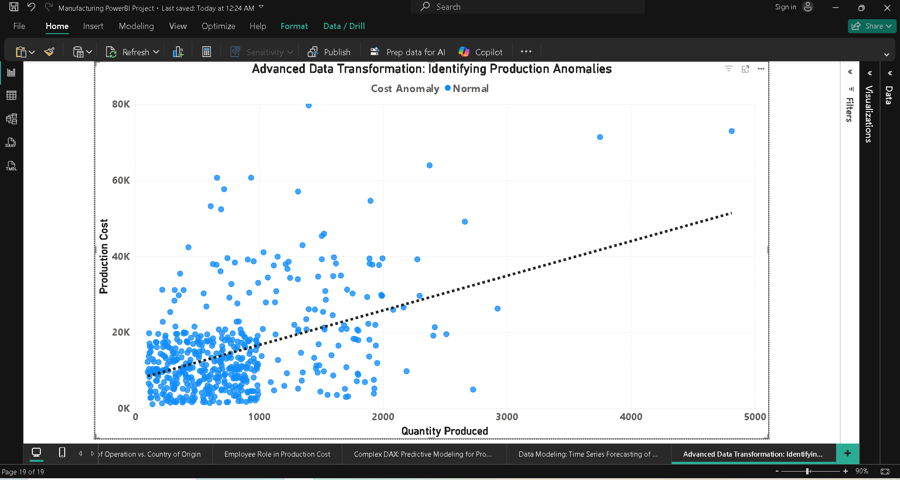

### **Metric / Logic Applied**

**Metrics:**

* Production Cost
* Quantity Produced
* Z-Score / Standard Deviation

**Logic:**

* Detects values deviating significantly from historical averages
* Uses statistical thresholds (±2 standard deviations)
* Flags unusual cost or quantity spikes

### **Insight / Observation**

The anomaly analysis highlights **several instances of unusually high production costs and sharp increases in production quantity**.  
 These anomalies may be caused by **raw material price fluctuations, machine downtime recovery, bulk production orders, or operational inefficiencies**.  
 Identifying these outliers enables management to **investigate root causes**, improve **process controls**, and **prevent cost overruns** in future production cycles.

### **Dashboards:**

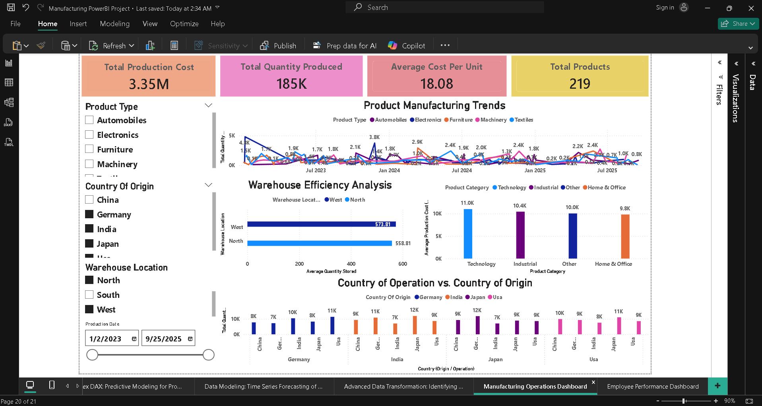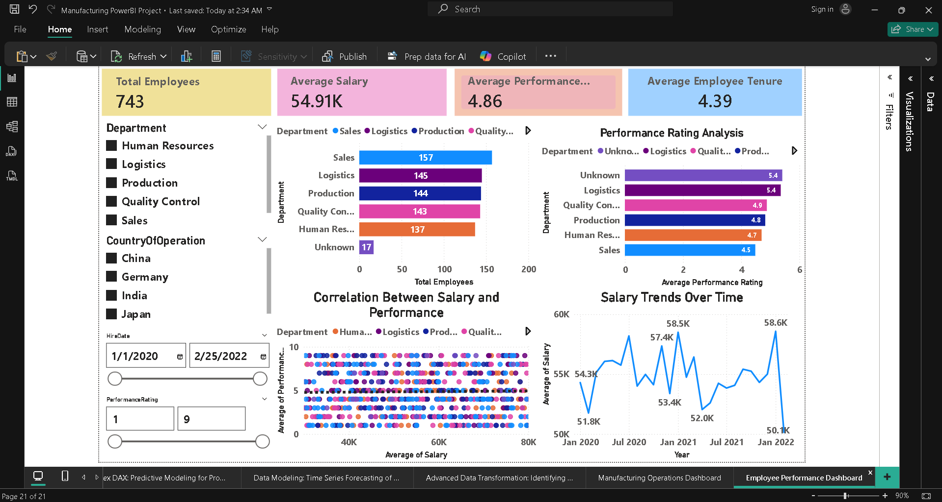

______________________________________________________________________________

## **Section 4: Overall Business Insights**

1. **Machinery products are the most cost-efficient**, with the lowest cost per unit, indicating optimized production processes.
2. **Textile products show higher production costs per unit**, highlighting opportunities for process improvement.
3. **Employee salaries peak around July and dip in January**, reflecting appraisal and hiring cycles.
4. **Higher employee performance ratings moderately correlate with higher salaries**, indicating performance-based compensation.
5. **Production anomalies and cost spikes** were identified, helping management focus on operational risk areas.

**______________________________________________________________________________**

## **Section 5: Reflection**

### **Challenges Faced**

* Handling inconsistent department values (NULL, -999, special characters)
* Resolving DAX errors related to ambiguous date values
* Designing a clean dashboard without overcrowding visuals
* Applying forecasting and anomaly detection correctly

### **Key Learnings**

* Hands-on experience with **Power Query transformations**
* Strong understanding of **data modeling and relationships**
* Practical use of **advanced DAX measures**
* Improved skills in **business storytelling using dashboards**

This project significantly enhanced my ability to analyze real-world manufacturing data and present insights in a structured, decision-oriented manner using Power BI.

**_________________________________________________________________________________________**

# **Power BI project folder link:**

## **https://drive.google.com/drive/folders/1KZD8Tx7nonQ3tikhu1A-06RpF-l38RUm?usp=sharing**

### Thank You!!